武汉纺织大学

Web应用开发课程设计

**基于SSM的学生选课系统**

**学 院： 数学与计算机学院**

**班 级： 物联网118012**

**姓 名： 杨乐诗**

**学 号： 1804240907**

**指导老师： 聂刚**

**成 绩：**

**完成日期： 2020年12月15日**

目 录

1 需求分析 1

1.1登陆 1

1.2主菜单 1

1.3各项功能 1

1.3.1 学生身份登录 1

1.3.2 老师身份登录 1

1.3.3 管理员身份登录 2

2 系统设计 3

2.1用户用例图 3

2.2 ER图 4

2.3 UML活动图（Activity Diagram） 6

2.3.1 登陆 6

2.3.2 学生 7

2.3.3 老师 8

2.3.4 管理员 8

3 系统实现 9

3.1 项目结构 9

3.2 配置文件 9

3.2.1 jdbc.properties文件 9

3.2.2 log4j.properties文件 9

3.2.3 mybatis-config.xml文件 10

3.3 VO类User.java 10

3.4 DAO接口类IUserDAO.java 11

3.5 接口映射文件UserMapper.xml 11

3.6 工具包Util 11

3.6.1 MybatisUtils.java 11

3.6.2 MD5Util.java 12

3.7 服务层UserService.java 13

3.8 用户界面Driver.java 14

3.9 ******.java 14

4 系统测试 14

5 系统总结 14

# 1 需求分析

设计一个基于ssm框架的学生选课系统，实现“登录”、“选课”、“退课”、“成绩查询”、“密码修改”等功能，具体要求如下：

## 1.1用户登陆

当程序运行时，会出现一个登录页面，可以选择登录人的身份，有学生、老师、管理员三个身份，选择学生身份登录后，可以进行选课，退选，查看选课结果和修改密码；选择老师身份进行登录后，可以进行查看选课名单，管理课程，录入成绩和修改密码；选择管理员身份登录后，可以进行学生课程和教师课程的管理。

## 1.2主菜单

## 当选择某个身份登录成功后，就会进入欢迎页面，还有显示时间、日期和导航栏。

## 1.3各项功能

### 1.3.1 学生身份登录成功

在导航栏中选择想要的操作，可以进行选课、退课、查看选课的内容、在个人信息中修改密码。

### 1.3.2 教师身份登录成功

在导航栏中选择想要的操作，可以进行添加教学课程、管理教学课程、查看名单和进行结课、录入成绩、在个人信息中修改密码。

### 1.3.3管理员身份登录成功

在导航栏中选择想要的操作，可以对老师、学生和课程进行管理，添加课程、添加老师和学生，在个人信息中修改密码。

# **2 系统设计**

## 2.1用户用例图

系统分为学生、老师和管理员三个角色，各角色的用户用例如下图2-1所示：

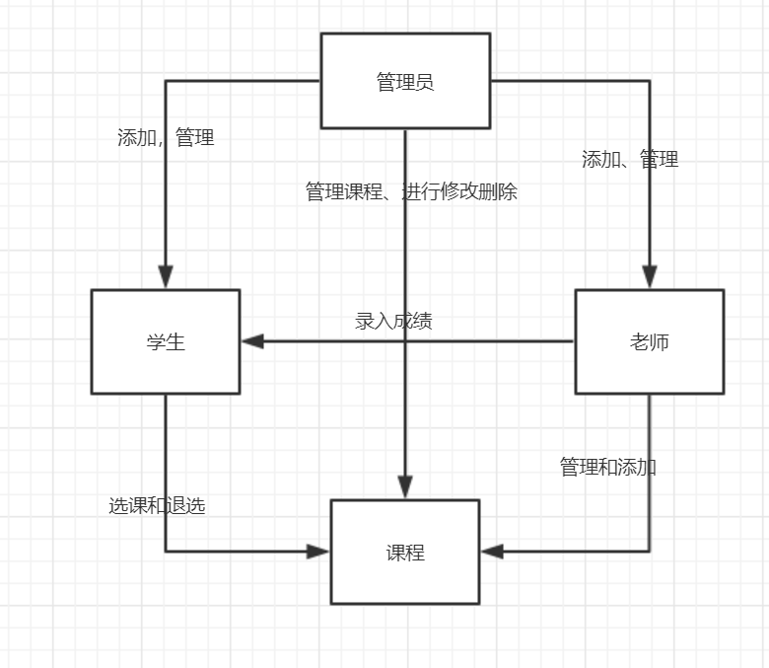

图2-1 用户用例图

## 2.2 ER图

数据库设计四张表，学生表，老师表，管理员表，课程表，对应的ER图如图3-1所示。

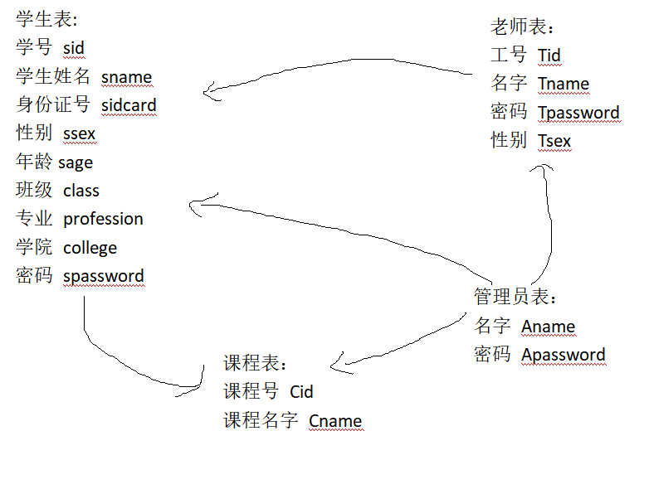

%3CmxGraphModel%3E%3Croot%3E%3CmxCell%20id%3D%220%22%2F%3E%3CmxCell%20id%3D%221%22%20parent%3D%220%22%2F%3E%3Cmysql.table%20entity.table.tableName%3D%22uses%22%20label%3D%22uses%22%20id%3D%222%22%3E%3CmxCell%20style%3D%22swimlane%3BfontStyle%3D0%3BchildLayout%3DstackLayout%3Bhorizontal%3D1%3Bhtml%3D1%3BstartSize%3D26%3BfillColor%3D%23b0e3e6%3BhorizontalStack%3D0%3BresizeParent%3D1%3BresizeParentMax%3D0%3BresizeLast%3D0%3Bcollapsible%3D1%3BmarginBottom%3D0%3BswimlaneFillColor%3D%23ffffff%3Balign%3Dcenter%3BfontSize%3D13%3BstrokeColor%3D%230e8088%3Brounded%3D0%3Bshadow%3D1%3Bcomic%3D0%3Bglass%3D0%3BgradientDirection%3Dsouth%3BgradientColor%3D%23ffffff%3B%22%20vertex%3D%221%22%20connectable%3D%220%22%20parent%3D%221%22%3E%3CmxGeometry%20x%3D%2260%22%20y%3D%2250%22%20width%3D%22310%22%20height%3D%22130%22%20as%3D%22geometry%22%2F%3E%3C%2FmxCell%3E%3C%2Fmysql.table%3E%3Cmysql.column%20entity.column.tableName%3D%22uses%22%20entity.column.name%3D%22userName%22%20entity.column.dataType%3D%22VARCHAR%22%20entity.column.PK%3D%22true%22%20label%3D%22%26lt%3Bimg%20title%3D%26quot%3BPrimary%20Key%26quot%3B%20src%3D%26quot%3Bimg%2Fdb%2Fkey1.png%26quot%3B%20width%3D%26quot%3B16%26quot%3B%20height%3D%26quot%3B16%26quot%3B%20align%3D%26quot%3Btop%26quot%3B%26gt%3B%26amp%3Bnbsp%3B%26lt%3Bfont%20size%3D%26quot%3B1%26quot%3B%20face%3D%26quot%3BTahoma%26quot%3B%26gt%3B%26lt%3Bspan%20style%3D%26quot%3Bfont-size%3A%2013px%26quot%3B%26gt%3B%26lt%3Bb%26gt%3Bid%20int%20primary%20key%26lt%3B%2Fb%26gt%3B%26lt%3B%2Fspan%26gt%3B%26lt%3B%2Ffont%26gt%3B%22%20entity.column.oldName%3D%22id%22%20entity.column.datalen%3D%2220%22%20entity.column.decimals%3D%22%22%20entity.column.autoIncreament%3D%22%22%20entity.column.unsigned%3D%22%22%20entity.column.bin%3D%22%22%20entity.column.ascii%3D%22%22%20entity.column.unicode%3D%22%22%20entity.column.unique%3D%22%22%20entity.column.isNotNull%3D%22NOT%20NULL%22%20entity.column.defaultValue%3D%22%22%20entity.column.comment%3D%22%22%20entity.column.enum%3D%22%22%20entity.column.set%3D%22%22%20entity.column.enumSetValue%3D%22%22%20id%3D%223%22%3E%3CmxCell%20style%3D%22text%3Bhtml%3D1%3BstrokeColor%3Dnone%3BfillColor%3Dnone%3BspacingLeft%3D4%3BspacingRight%3D4%3Boverflow%3Dhidden%3Brotatable%3D0%3BportConstraint%3Deastwest%3BfontSize%3D12%3BverticalAlign%3Dmiddle%3B%22%20vertex%3D%221%22%20parent%3D%222%22%3E%3CmxGeometry%20y%3D%2226%22%20width%3D%22310%22%20height%3D%2226%22%20as%3D%22geometry%22%2F%3E%3C%2FmxCell%3E%3C%2Fmysql.column%3E%3Cmysql.column%20entity.column.tableName%3D%22uses%22%20entity.column.name%3D%22chrName%22%20entity.column.datalen%3D%2220%22%20entity.column.dataType%3D%22VARCHAR%22%20label%3D%22%26lt%3Bimg%20title%3D%26quot%3BPrimary%20Key%26quot%3B%20src%3D%26quot%3Bimages%2Fspacer.gif%26quot%3B%20width%3D%26quot%3B16%26quot%3B%20height%3D%26quot%3B16%26quot%3B%20align%3D%26quot%3Btop%26quot%3B%26gt%3B%26amp%3Bnbsp%3B%26lt%3Bfont%20size%3D%26quot%3B1%26quot%3B%20face%3D%26quot%3BTahoma%26quot%3B%26gt%3B%26lt%3Bspan%20style%3D%26quot%3Bfont-size%3A%2013px%26quot%3B%26gt%3B%26lt%3Bb%26gt%3Bname%20varchar(10)%26lt%3B%2Fb%26gt%3B%26lt%3B%2Fspan%26gt%3B%26lt%3B%2Ffont%26gt%3B%22%20entity.column.oldName%3D%22name%22%20entity.column.decimals%3D%22%22%20entity.column.autoIncreament%3D%22%22%20entity.column.unsigned%3D%22%22%20entity.column.bin%3D%22%22%20entity.column.ascii%3D%22%22%20entity.column.unicode%3D%22%22%20entity.column.PK%3D%22false%22%20entity.column.unique%3D%22%22%20entity.column.isNotNull%3D%22%22%20entity.column.defaultValue%3D%22%22%20entity.column.comment%3D%22%22%20entity.column.enum%3D%22%22%20entity.column.set%3D%22%22%20entity.column.enumSetValue%3D%22%22%20id%3D%224%22%3E%3CmxCell%20style%3D%22text%3Bhtml%3D1%3BstrokeColor%3Dnone%3BfillColor%3Dnone%3BspacingLeft%3D4%3BspacingRight%3D4%3Boverflow%3Dhidden%3Brotatable%3D0%3BportConstraint%3Deastwest%3BfontSize%3D12%3BverticalAlign%3Dmiddle%3B%22%20vertex%3D%221%22%20parent%3D%222%22%3E%3CmxGeometry%20y%3D%2252%22%20width%3D%22310%22%20height%3D%2226%22%20as%3D%22geometry%22%2F%3E%3C%2FmxCell%3E%3C%2Fmysql.column%3E%3Cmysql.column%20entity.column.tableName%3D%22uses%22%20entity.column.name%3D%22password%22%20entity.column.datalen%3D%2250%22%20entity.column.dataType%3D%22VARCHAR%22%20label%3D%22%26lt%3Bimg%20title%3D%26quot%3BPrimary%20Key%26quot%3B%20src%3D%26quot%3Bimages%2Fspacer.gif%26quot%3B%20width%3D%26quot%3B16%26quot%3B%20height%3D%26quot%3B16%26quot%3B%20align%3D%26quot%3Btop%26quot%3B%26gt%3B%26amp%3Bnbsp%3B%26lt%3Bfont%20size%3D%26quot%3B1%26quot%3B%20face%3D%26quot%3BTahoma%26quot%3B%26gt%3B%26lt%3Bspan%20style%3D%26quot%3Bfont-size%3A%2013px%26quot%3B%26gt%3B%26lt%3Bb%26gt%3Bname%20varchar(10)%26lt%3B%2Fb%26gt%3B%26lt%3B%2Fspan%26gt%3B%26lt%3B%2Ffont%26gt%3B%22%20entity.column.oldName%3D%22chrName%22%20entity.column.decimals%3D%22%22%20entity.column.autoIncreament%3D%22%22%20entity.column.unsigned%3D%22%22%20entity.column.bin%3D%22%22%20entity.column.ascii%3D%22%22%20entity.column.unicode%3D%22%22%20entity.column.PK%3D%22false%22%20entity.column.unique%3D%22%22%20entity.column.isNotNull%3D%22%22%20entity.column.defaultValue%3D%22%22%20entity.column.comment%3D%22%E5%AF%86%E7%A0%81%22%20entity.column.enum%3D%22%22%20entity.column.set%3D%22%22%20entity.column.enumSetValue%3D%22%22%20id%3D%225%22%3E%3CmxCell%20style%3D%22text%3Bhtml%3D1%3BstrokeColor%3Dnone%3BfillColor%3Dnone%3BspacingLeft%3D4%3BspacingRight%3D4%3Boverflow%3Dhidden%3Brotatable%3D0%3BportConstraint%3Deastwest%3BfontSize%3D12%3BverticalAlign%3Dmiddle%3B%22%20vertex%3D%221%22%20parent%3D%222%22%3E%3CmxGeometry%20y%3D%2278%22%20width%3D%22310%22%20height%3D%2226%22%20as%3D%22geometry%22%2F%3E%3C%2FmxCell%3E%3C%2Fmysql.column%3E%3Cmysql.column%20entity.column.tableName%3D%22uses%22%20entity.column.name%3D%22role%22%20entity.column.datalen%3D%2220%22%20entity.column.dataType%3D%22VARCHAR%22%20label%3D%22%26lt%3Bimg%20title%3D%26quot%3BPrimary%20Key%26quot%3B%20src%3D%26quot%3Bimages%2Fspacer.gif%26quot%3B%20width%3D%26quot%3B16%26quot%3B%20height%3D%26quot%3B16%26quot%3B%20align%3D%26quot%3Btop%26quot%3B%26gt%3B%26amp%3Bnbsp%3B%26lt%3Bfont%20size%3D%26quot%3B1%26quot%3B%20face%3D%26quot%3BTahoma%26quot%3B%26gt%3B%26lt%3Bspan%20style%3D%26quot%3Bfont-size%3A%2013px%26quot%3B%26gt%3B%26lt%3Bb%26gt%3Bname%20varchar(10)%26lt%3B%2Fb%26gt%3B%26lt%3B%2Fspan%26gt%3B%26lt%3B%2Ffont%26gt%3B%22%20entity.column.oldName%3D%22chrName%22%20entity.column.decimals%3D%22%22%20entity.column.autoIncreament%3D%22%22%20entity.column.unsigned%3D%22%22%20entity.column.bin%3D%22%22%20entity.column.ascii%3D%22%22%20entity.column.unicode%3D%22%22%20entity.column.PK%3D%22false%22%20entity.column.unique%3D%22%22%20entity.column.isNotNull%3D%22%22%20entity.column.defaultValue%3D%22%22%20entity.column.comment%3D%22%E8%A7%92%E8%89%B2%22%20entity.column.enum%3D%22%22%20entity.column.set%3D%22%22%20entity.column.enumSetValue%3D%22%22%20id%3D%226%22%3E%3CmxCell%20style%3D%22text%3Bhtml%3D1%3BstrokeColor%3Dnone%3BfillColor%3Dnone%3BspacingLeft%3D4%3BspacingRight%3D4%3Boverflow%3Dhidden%3Brotatable%3D0%3BportConstraint%3Deastwest%3BfontSize%3D12%3BverticalAlign%3Dmiddle%3B%22%20vertex%3D%221%22%20parent%3D%222%22%3E%3CmxGeometry%20y%3D%22104%22%20width%3D%22310%22%20height%3D%2226%22%20as%3D%22geometry%22%2F%3E%3C%2FmxCell%3E%3C%2Fmysql.column%3E%3Cmysql.table%20entity.table.tableName%3D%22product%22%20label%3D%22product%22%20id%3D%227%22%3E%3CmxCell%20style%3D%22swimlane%3BfontStyle%3D0%3BchildLayout%3DstackLayout%3Bhorizontal%3D1%3Bhtml%3D1%3BstartSize%3D26%3BfillColor%3D%23b0e3e6%3BhorizontalStack%3D0%3BresizeParent%3D1%3BresizeParentMax%3D0%3BresizeLast%3D0%3Bcollapsible%3D1%3BmarginBottom%3D0%3BswimlaneFillColor%3D%23ffffff%3Balign%3Dcenter%3BfontSize%3D13%3BstrokeColor%3D%230e8088%3Brounded%3D0%3Bshadow%3D1%3Bcomic%3D0%3Bglass%3D0%3BgradientDirection%3Dsouth%3BgradientColor%3D%23ffffff%3B%22%20vertex%3D%221%22%20connectable%3D%220%22%20parent%3D%221%22%3E%3CmxGeometry%20x%3D%2260%22%20y%3D%22210%22%20width%3D%22310%22%20height%3D%22130%22%20as%3D%22geometry%22%2F%3E%3C%2FmxCell%3E%3C%2Fmysql.table%3E%3Cmysql.column%20entity.column.tableName%3D%22product%22%20entity.column.name%3D%22barcode%22%20entity.column.dataType%3D%22VARCHAR%22%20entity.column.PK%3D%22true%22%20label%3D%22%26lt%3Bimg%20title%3D%26quot%3BPrimary%20Key%26quot%3B%20src%3D%26quot%3Bimg%2Fdb%2Fkey1.png%26quot%3B%20width%3D%26quot%3B16%26quot%3B%20height%3D%26quot%3B16%26quot%3B%20align%3D%26quot%3Btop%26quot%3B%26gt%3B%26amp%3Bnbsp%3B%26lt%3Bfont%20size%3D%26quot%3B1%26quot%3B%20face%3D%26quot%3BTahoma%26quot%3B%26gt%3B%26lt%3Bspan%20style%3D%26quot%3Bfont-size%3A%2013px%26quot%3B%26gt%3B%26lt%3Bb%26gt%3Bid%20int%20primary%20key%26lt%3B%2Fb%26gt%3B%26lt%3B%2Fspan%26gt%3B%26lt%3B%2Ffont%26gt%3B%22%20entity.column.oldName%3D%22id%22%20entity.column.datalen%3D%2210%22%20entity.column.decimals%3D%22%22%20entity.column.autoIncreament%3D%22%22%20entity.column.unsigned%3D%22%22%20entity.column.bin%3D%22%22%20entity.column.ascii%3D%22%22%20entity.column.unicode%3D%22%22%20entity.column.unique%3D%22%22%20entity.column.isNotNull%3D%22NOT%20NULL%22%20entity.column.defaultValue%3D%22%22%20entity.column.comment%3D%22%22%20entity.column.enum%3D%22%22%20entity.column.set%3D%22%22%20entity.column.enumSetValue%3D%22%22%20id%3D%228%22%3E%3CmxCell%20style%3D%22text%3Bhtml%3D1%3BstrokeColor%3Dnone%3BfillColor%3Dnone%3BspacingLeft%3D4%3BspacingRight%3D4%3Boverflow%3Dhidden%3Brotatable%3D0%3BportConstraint%3Deastwest%3BfontSize%3D12%3BverticalAlign%3Dmiddle%3B%22%20vertex%3D%221%22%20parent%3D%227%22%3E%3CmxGeometry%20y%3D%2226%22%20width%3D%22310%22%20height%3D%2226%22%20as%3D%22geometry%22%2F%3E%3C%2FmxCell%3E%3C%2Fmysql.column%3E%3Cmysql.column%20entity.column.tableName%3D%22product%22%20entity.column.name%3D%22productName%22%20entity.column.datalen%3D%2250%22%20entity.column.dataType%3D%22VARCHAR%22%20label%3D%22%26lt%3Bimg%20title%3D%26quot%3BPrimary%20Key%26quot%3B%20src%3D%26quot%3Bimages%2Fspacer.gif%26quot%3B%20width%3D%26quot%3B16%26quot%3B%20height%3D%26quot%3B16%26quot%3B%20align%3D%26quot%3Btop%26quot%3B%26gt%3B%26amp%3Bnbsp%3B%26lt%3Bfont%20size%3D%26quot%3B1%26quot%3B%20face%3D%26quot%3BTahoma%26quot%3B%26gt%3B%26lt%3Bspan%20style%3D%26quot%3Bfont-size%3A%2013px%26quot%3B%26gt%3B%26lt%3Bb%26gt%3Bname%20varchar(10)%26lt%3B%2Fb%26gt%3B%26lt%3B%2Fspan%26gt%3B%26lt%3B%2Ffont%26gt%3B%22%20entity.column.oldName%3D%22name%22%20entity.column.decimals%3D%22%22%20entity.column.autoIncreament%3D%22%22%20entity.column.unsigned%3D%22%22%20entity.column.bin%3D%22%22%20entity.column.ascii%3D%22%22%20entity.column.unicode%3D%22%22%20entity.column.PK%3D%22false%22%20entity.column.unique%3D%22%22%20entity.column.isNotNull%3D%22%22%20entity.column.defaultValue%3D%22%22%20entity.column.comment%3D%22%22%20entity.column.enum%3D%22%22%20entity.column.set%3D%22%22%20entity.column.enumSetValue%3D%22%22%20id%3D%229%22%3E%3CmxCell%20style%3D%22text%3Bhtml%3D1%3BstrokeColor%3Dnone%3BfillColor%3Dnone%3BspacingLeft%3D4%3BspacingRight%3D4%3Boverflow%3Dhidden%3Brotatable%3D0%3BportConstraint%3Deastwest%3BfontSize%3D12%3BverticalAlign%3Dmiddle%3B%22%20vertex%3D%221%22%20parent%3D%227%22%3E%3CmxGeometry%20y%3D%2252%22%20width%3D%22310%22%20height%3D%2226%22%20as%3D%22geometry%22%2F%3E%3C%2FmxCell%3E%3C%2Fmysql.column%3E%3Cmysql.column%20entity.column.tableName%3D%22product%22%20entity.column.name%3D%22price%22%20entity.column.datalen%3D%229%22%20entity.column.dataType%3D%22DECIMAL%22%20label%3D%22%26lt%3Bimg%20title%3D%26quot%3BPrimary%20Key%26quot%3B%20src%3D%26quot%3Bimages%2Fspacer.gif%26quot%3B%20width%3D%26quot%3B16%26quot%3B%20height%3D%26quot%3B16%26quot%3B%20align%3D%26quot%3Btop%26quot%3B%26gt%3B%26amp%3Bnbsp%3B%26lt%3Bfont%20size%3D%26quot%3B1%26quot%3B%20face%3D%26quot%3BTahoma%26quot%3B%26gt%3B%26lt%3Bspan%20style%3D%26quot%3Bfont-size%3A%2013px%26quot%3B%26gt%3B%26lt%3Bb%26gt%3Bname%20varchar(10)%26lt%3B%2Fb%26gt%3B%26lt%3B%2Fspan%26gt%3B%26lt%3B%2Ffont%26gt%3B%22%20entity.column.oldName%3D%22price%22%20entity.column.decimals%3D%222%22%20entity.column.autoIncreament%3D%22%22%20entity.column.unsigned%3D%22%22%20entity.column.bin%3D%22%22%20entity.column.ascii%3D%22%22%20entity.column.unicode%3D%22%22%20entity.column.PK%3D%22false%22%20entity.column.unique%3D%22%22%20entity.column.isNotNull%3D%22%22%20entity.column.defaultValue%3D%22%22%20entity.column.comment%3D%22%22%20entity.column.enum%3D%22%22%20entity.column.set%3D%22%22%20entity.column.enumSetValue%3D%22%22%20id%3D%2210%22%3E%3CmxCell%20style%3D%22text%3Bhtml%3D1%3BstrokeColor%3Dnone%3BfillColor%3Dnone%3BspacingLeft%3D4%3BspacingRight%3D4%3Boverflow%3Dhidden%3Brotatable%3D0%3BportConstraint%3Deastwest%3BfontSize%3D12%3BverticalAlign%3Dmiddle%3B%22%20vertex%3D%221%22%20parent%3D%227%22%3E%3CmxGeometry%20y%3D%2278%22%20width%3D%22310%22%20height%3D%2226%22%20as%3D%22geometry%22%2F%3E%3C%2FmxCell%3E%3C%2Fmysql.column%3E%3Cmysql.column%20entity.column.tableName%3D%22product%22%20entity.column.name%3D%22supply%22%20entity.column.datalen%3D%2220%22%20entity.column.dataType%3D%22VARCHAR%22%20label%3D%22%26lt%3Bimg%20title%3D%26quot%3BPrimary%20Key%26quot%3B%20src%3D%26quot%3Bimages%2Fspacer.gif%26quot%3B%20width%3D%26quot%3B16%26quot%3B%20height%3D%26quot%3B16%26quot%3B%20align%3D%26quot%3Btop%26quot%3B%26gt%3B%26amp%3Bnbsp%3B%26lt%3Bfont%20size%3D%26quot%3B1%26quot%3B%20face%3D%26quot%3BTahoma%26quot%3B%26gt%3B%26lt%3Bspan%20style%3D%26quot%3Bfont-size%3A%2013px%26quot%3B%26gt%3B%26lt%3Bb%26gt%3Bname%20varchar(10)%26lt%3B%2Fb%26gt%3B%26lt%3B%2Fspan%26gt%3B%26lt%3B%2Ffont%26gt%3B%22%20entity.column.oldName%3D%22price%22%20entity.column.decimals%3D%22%22%20entity.column.autoIncreament%3D%22%22%20entity.column.unsigned%3D%22%22%20entity.column.bin%3D%22%22%20entity.column.ascii%3D%22%22%20entity.column.unicode%3D%22%22%20entity.column.PK%3D%22false%22%20entity.column.unique%3D%22%22%20entity.column.isNotNull%3D%22%22%20entity.column.defaultValue%3D%22%22%20entity.column.comment%3D%22%22%20entity.column.enum%3D%22%22%20entity.column.set%3D%22%22%20entity.column.enumSetValue%3D%22%22%20id%3D%2211%22%3E%3CmxCell%20style%3D%22text%3Bhtml%3D1%3BstrokeColor%3Dnone%3BfillColor%3Dnone%3BspacingLeft%3D4%3BspacingRight%3D4%3Boverflow%3Dhidden%3Brotatable%3D0%3BportConstraint%3Deastwest%3BfontSize%3D12%3BverticalAlign%3Dmiddle%3B%22%20vertex%3D%221%22%20parent%3D%227%22%3E%3CmxGeometry%20y%3D%22104%22%20width%3D%22310%22%20height%3D%2226%22%20as%3D%22geometry%22%2F%3E%3C%2FmxCell%3E%3C%2Fmysql.column%3E%3Cmysql.table%20entity.table.tableName%3D%22saleDetail%22%20label%3D%22saleDetail%22%20id%3D%2212%22%3E%3CmxCell%20style%3D%22swimlane%3BfontStyle%3D0%3BchildLayout%3DstackLayout%3Bhorizontal%3D1%3Bhtml%3D1%3BstartSize%3D26%3BfillColor%3D%23b0e3e6%3BhorizontalStack%3D0%3BresizeParent%3D1%3BresizeParentMax%3D0%3BresizeLast%3D0%3Bcollapsible%3D1%3BmarginBottom%3D0%3BswimlaneFillColor%3D%23ffffff%3Balign%3Dcenter%3BfontSize%3D13%3BstrokeColor%3D%230e8088%3Brounded%3D0%3Bshadow%3D1%3Bcomic%3D0%3Bglass%3D0%3BgradientDirection%3Dsouth%3BgradientColor%3D%23ffffff%3B%22%20vertex%3D%221%22%20connectable%3D%220%22%20parent%3D%221%22%3E%3CmxGeometry%20x%3D%22480%22%20y%3D%2280%22%20width%3D%22280%22%20height%3D%22208%22%20as%3D%22geometry%22%2F%3E%3C%2FmxCell%3E%3C%2Fmysql.table%3E%3Cmysql.column%20entity.column.tableName%3D%22saleDetail%22%20entity.column.name%3D%22lsh%22%20entity.column.dataType%3D%22VARCHAR%22%20entity.column.PK%3D%22true%22%20label%3D%22%26lt%3Bimg%20title%3D%26quot%3BPrimary%20Key%26quot%3B%20src%3D%26quot%3Bimg%2Fdb%2Fkey1.png%26quot%3B%20width%3D%26quot%3B16%26quot%3B%20height%3D%26quot%3B16%26quot%3B%20align%3D%26quot%3Btop%26quot%3B%26gt%3B%26amp%3Bnbsp%3B%26lt%3Bfont%20size%3D%26quot%3B1%26quot%3B%20face%3D%26quot%3BTahoma%26quot%3B%26gt%3B%26lt%3Bspan%20style%3D%26quot%3Bfont-size%3A%2013px%26quot%3B%26gt%3B%26lt%3Bb%26gt%3Bid%20int%20primary%20key%26lt%3B%2Fb%26gt%3B%26lt%3B%2Fspan%26gt%3B%26lt%3B%2Ffont%26gt%3B%22%20entity.column.oldName%3D%22id%22%20entity.column.datalen%3D%2220%22%20entity.column.decimals%3D%22%22%20entity.column.autoIncreament%3D%22%22%20entity.column.unsigned%3D%22%22%20entity.column.bin%3D%22%22%20entity.column.ascii%3D%22%22%20entity.column.unicode%3D%22%22%20entity.column.unique%3D%22%22%20entity.column.isNotNull%3D%22NOT%20NULL%22%20entity.column.defaultValue%3D%22%22%20entity.column.comment%3D%22%22%20entity.column.enum%3D%22%22%20entity.column.set%3D%22%22%20entity.column.enumSetValue%3D%22%22%20id%3D%2213%22%3E%3CmxCell%20style%3D%22text%3Bhtml%3D1%3BstrokeColor%3Dnone%3BfillColor%3Dnone%3BspacingLeft%3D4%3BspacingRight%3D4%3Boverflow%3Dhidden%3Brotatable%3D0%3BportConstraint%3Deastwest%3BfontSize%3D12%3BverticalAlign%3Dmiddle%3B%22%20vertex%3D%221%22%20parent%3D%2212%22%3E%3CmxGeometry%20y%3D%2226%22%20width%3D%22280%22%20height%3D%2226%22%20as%3D%22geometry%22%2F%3E%3C%2FmxCell%3E%3C%2Fmysql.column%3E%3Cmysql.column%20entity.column.tableName%3D%22saleDetail%22%20entity.column.name%3D%22barcode%22%20entity.column.datalen%3D%2210%22%20entity.column.dataType%3D%22VARCHAR%22%20label%3D%22%26lt%3Bimg%20title%3D%26quot%3BPrimary%20Key%26quot%3B%20src%3D%26quot%3Bimages%2Fspacer.gif%26quot%3B%20width%3D%26quot%3B16%26quot%3B%20height%3D%26quot%3B16%26quot%3B%20align%3D%26quot%3Btop%26quot%3B%26gt%3B%26amp%3Bnbsp%3B%26lt%3Bfont%20size%3D%26quot%3B1%26quot%3B%20face%3D%26quot%3BTahoma%26quot%3B%26gt%3B%26lt%3Bspan%20style%3D%26quot%3Bfont-size%3A%2013px%26quot%3B%26gt%3B%26lt%3Bb%26gt%3Bname%20varchar(10)%26lt%3B%2Fb%26gt%3B%26lt%3B%2Fspan%26gt%3B%26lt%3B%2Ffont%26gt%3B%22%20entity.column.oldName%3D%22barcode%22%20entity.column.decimals%3D%22%22%20entity.column.autoIncreament%3D%22%22%20entity.column.unsigned%3D%22%22%20entity.column.bin%3D%22%22%20entity.column.ascii%3D%22%22%20entity.column.unicode%3D%22%22%20entity.column.PK%3D%22false%22%20entity.column.unique%3D%22%22%20entity.column.isNotNull%3D%22%22%20entity.column.defaultValue%3D%22%22%20entity.column.comment%3D%22%22%20entity.column.enum%3D%22%22%20entity.column.set%3D%22%22%20entity.column.enumSetValue%3D%22%22%20id%3D%2214%22%3E%3CmxCell%20style%3D%22text%3Bhtml%3D1%3BstrokeColor%3Dnone%3BfillColor%3Dnone%3BspacingLeft%3D4%3BspacingRight%3D4%3Boverflow%3Dhidden%3Brotatable%3D0%3BportConstraint%3Deastwest%3BfontSize%3D12%3BverticalAlign%3Dmiddle%3B%22%20vertex%3D%221%22%20parent%3D%2212%22%3E%3CmxGeometry%20y%3D%2252%22%20width%3D%22280%22%20height%3D%2226%22%20as%3D%22geometry%22%2F%3E%3C%2FmxCell%3E%3C%2Fmysql.column%3E%3Cmysql.column%20entity.column.tableName%3D%22saleDetail%22%20entity.column.name%3D%22productName%22%20entity.column.datalen%3D%2250%22%20entity.column.dataType%3D%22VARCHAR%22%20label%3D%22%26lt%3Bimg%20title%3D%26quot%3BPrimary%20Key%26quot%3B%20src%3D%26quot%3Bimages%2Fspacer.gif%26quot%3B%20width%3D%26quot%3B16%26quot%3B%20height%3D%26quot%3B16%26quot%3B%20align%3D%26quot%3Btop%26quot%3B%26gt%3B%26amp%3Bnbsp%3B%26lt%3Bfont%20size%3D%26quot%3B1%26quot%3B%20face%3D%26quot%3BTahoma%26quot%3B%26gt%3B%26lt%3Bspan%20style%3D%26quot%3Bfont-size%3A%2013px%26quot%3B%26gt%3B%26lt%3Bb%26gt%3Bname%20varchar(10)%26lt%3B%2Fb%26gt%3B%26lt%3B%2Fspan%26gt%3B%26lt%3B%2Ffont%26gt%3B%22%20entity.column.oldName%3D%22productName%22%20entity.column.decimals%3D%22%22%20entity.column.autoIncreament%3D%22%22%20entity.column.unsigned%3D%22%22%20entity.column.bin%3D%22%22%20entity.column.ascii%3D%22%22%20entity.column.unicode%3D%22%22%20entity.column.PK%3D%22false%22%20entity.column.unique%3D%22%22%20entity.column.isNotNull%3D%22%22%20entity.column.defaultValue%3D%22%22%20entity.column.comment%3D%22%22%20entity.column.enum%3D%22%22%20entity.column.set%3D%22%22%20entity.column.enumSetValue%3D%22%22%20id%3D%2215%22%3E%3CmxCell%20style%3D%22text%3Bhtml%3D1%3BstrokeColor%3Dnone%3BfillColor%3Dnone%3BspacingLeft%3D4%3BspacingRight%3D4%3Boverflow%3Dhidden%3Brotatable%3D0%3BportConstraint%3Deastwest%3BfontSize%3D12%3BverticalAlign%3Dmiddle%3B%22%20vertex%3D%221%22%20parent%3D%2212%22%3E%3CmxGeometry%20y%3D%2278%22%20width%3D%22280%22%20height%3D%2226%22%20as%3D%22geometry%22%2F%3E%3C%2FmxCell%3E%3C%2Fmysql.column%3E%3Cmysql.column%20entity.column.tableName%3D%22saleDetail%22%20entity.column.name%3D%22price%22%20entity.column.datalen%3D%229%22%20entity.column.dataType%3D%22DECIMAL%22%20label%3D%22%26lt%3Bimg%20title%3D%26quot%3BPrimary%20Key%26quot%3B%20src%3D%26quot%3Bimages%2Fspacer.gif%26quot%3B%20width%3D%26quot%3B16%26quot%3B%20height%3D%26quot%3B16%26quot%3B%20align%3D%26quot%3Btop%26quot%3B%26gt%3B%26amp%3Bnbsp%3B%26lt%3Bfont%20size%3D%26quot%3B1%26quot%3B%20face%3D%26quot%3BTahoma%26quot%3B%26gt%3B%26lt%3Bspan%20style%3D%26quot%3Bfont-size%3A%2013px%26quot%3B%26gt%3B%26lt%3Bb%26gt%3Bname%20varchar(10)%26lt%3B%2Fb%26gt%3B%26lt%3B%2Fspan%26gt%3B%26lt%3B%2Ffont%26gt%3B%22%20entity.column.oldName%3D%22productName%22%20entity.column.decimals%3D%222%22%20entity.column.autoIncreament%3D%22%22%20entity.column.unsigned%3D%22%22%20entity.column.bin%3D%22%22%20entity.column.ascii%3D%22%22%20entity.column.unicode%3D%22%22%20entity.column.PK%3D%22false%22%20entity.column.unique%3D%22%22%20entity.column.isNotNull%3D%22%22%20entity.column.defaultValue%3D%22%22%20entity.column.comment%3D%22%22%20entity.column.enum%3D%22%22%20entity.column.set%3D%22%22%20entity.column.enumSetValue%3D%22%22%20id%3D%2216%22%3E%3CmxCell%20style%3D%22text%3Bhtml%3D1%3BstrokeColor%3Dnone%3BfillColor%3Dnone%3BspacingLeft%3D4%3BspacingRight%3D4%3Boverflow%3Dhidden%3Brotatable%3D0%3BportConstraint%3Deastwest%3BfontSize%3D12%3BverticalAlign%3Dmiddle%3B%22%20vertex%3D%221%22%20parent%3D%2212%22%3E%3CmxGeometry%20y%3D%22104%22%20width%3D%22280%22%20height%3D%2226%22%20as%3D%22geometry%22%2F%3E%3C%2FmxCell%3E%3C%2Fmysql.column%3E%3Cmysql.column%20entity.column.tableName%3D%22saleDetail%22%20entity.column.name%3D%22count%22%20entity.column.datalen%3D%229%22%20entity.column.dataType%3D%22INT%22%20label%3D%22%26lt%3Bimg%20title%3D%26quot%3BPrimary%20Key%26quot%3B%20src%3D%26quot%3Bimages%2Fspacer.gif%26quot%3B%20width%3D%26quot%3B16%26quot%3B%20height%3D%26quot%3B16%26quot%3B%20align%3D%26quot%3Btop%26quot%3B%26gt%3B%26amp%3Bnbsp%3B%26lt%3Bfont%20size%3D%26quot%3B1%26quot%3B%20face%3D%26quot%3BTahoma%26quot%3B%26gt%3B%26lt%3Bspan%20style%3D%26quot%3Bfont-size%3A%2013px%26quot%3B%26gt%3B%26lt%3Bb%26gt%3Bname%20varchar(10)%26lt%3B%2Fb%26gt%3B%26lt%3B%2Fspan%26gt%3B%26lt%3B%2Ffont%26gt%3B%22%20entity.column.oldName%3D%22price%22%20entity.column.decimals%3D%22%22%20entity.column.autoIncreament%3D%22%22%20entity.column.unsigned%3D%22%22%20entity.column.bin%3D%22%22%20entity.column.ascii%3D%22%22%20entity.column.unicode%3D%22%22%20entity.column.PK%3D%22false%22%20entity.column.unique%3D%22%22%20entity.column.isNotNull%3D%22%22%20entity.column.defaultValue%3D%22%22%20entity.column.comment%3D%22%22%20entity.column.enum%3D%22%22%20entity.column.set%3D%22%22%20entity.column.enumSetValue%3D%22%22%20id%3D%2217%22%3E%3CmxCell%20style%3D%22text%3Bhtml%3D1%3BstrokeColor%3Dnone%3BfillColor%3Dnone%3BspacingLeft%3D4%3BspacingRight%3D4%3Boverflow%3Dhidden%3Brotatable%3D0%3BportConstraint%3Deastwest%3BfontSize%3D12%3BverticalAlign%3Dmiddle%3B%22%20vertex%3D%221%22%20parent%3D%2212%22%3E%3CmxGeometry%20y%3D%22130%22%20width%3D%22280%22%20height%3D%2226%22%20as%3D%22geometry%22%2F%3E%3C%2FmxCell%3E%3C%2Fmysql.column%3E%3Cmysql.column%20entity.column.tableName%3D%22saleDetail%22%20entity.column.name%3D%22operator%22%20entity.column.datalen%3D%2220%22%20entity.column.dataType%3D%22VARCHAR%22%20label%3D%22%26lt%3Bimg%20title%3D%26quot%3BPrimary%20Key%26quot%3B%20src%3D%26quot%3Bimages%2Fspacer.gif%26quot%3B%20width%3D%26quot%3B16%26quot%3B%20height%3D%26quot%3B16%26quot%3B%20align%3D%26quot%3Btop%26quot%3B%26gt%3B%26amp%3Bnbsp%3B%26lt%3Bfont%20size%3D%26quot%3B1%26quot%3B%20face%3D%26quot%3BTahoma%26quot%3B%26gt%3B%26lt%3Bspan%20style%3D%26quot%3Bfont-size%3A%2013px%26quot%3B%26gt%3B%26lt%3Bb%26gt%3Bname%20varchar(10)%26lt%3B%2Fb%26gt%3B%26lt%3B%2Fspan%26gt%3B%26lt%3B%2Ffont%26gt%3B%22%20entity.column.oldName%3D%22count%22%20entity.column.decimals%3D%22%22%20entity.column.autoIncreament%3D%22%22%20entity.column.unsigned%3D%22%22%20entity.column.bin%3D%22%22%20entity.column.ascii%3D%22%22%20entity.column.unicode%3D%22%22%20entity.column.PK%3D%22false%22%20entity.column.unique%3D%22%22%20entity.column.isNotNull%3D%22%22%20entity.column.defaultValue%3D%22%22%20entity.column.comment%3D%22%22%20entity.column.enum%3D%22%22%20entity.column.set%3D%22%22%20entity.column.enumSetValue%3D%22%22%20id%3D%2218%22%3E%3CmxCell%20style%3D%22text%3Bhtml%3D1%3BstrokeColor%3Dnone%3BfillColor%3Dnone%3BspacingLeft%3D4%3BspacingRight%3D4%3Boverflow%3Dhidden%3Brotatable%3D0%3BportConstraint%3Deastwest%3BfontSize%3D12%3BverticalAlign%3Dmiddle%3B%22%20vertex%3D%221%22%20parent%3D%2212%22%3E%3CmxGeometry%20y%3D%22156%22%20width%3D%22280%22%20height%3D%2226%22%20as%3D%22geometry%22%2F%3E%3C%2FmxCell%3E%3C%2Fmysql.column%3E%3Cmysql.column%20entity.column.tableName%3D%22saleDetail%22%20entity.column.name%3D%22saleTime%22%20entity.column.datalen%3D%22%22%20entity.column.dataType%3D%22DATETIME%22%20label%3D%22%26lt%3Bimg%20title%3D%26quot%3BPrimary%20Key%26quot%3B%20src%3D%26quot%3Bimages%2Fspacer.gif%26quot%3B%20width%3D%26quot%3B16%26quot%3B%20height%3D%26quot%3B16%26quot%3B%20align%3D%26quot%3Btop%26quot%3B%26gt%3B%26amp%3Bnbsp%3B%26lt%3Bfont%20size%3D%26quot%3B1%26quot%3B%20face%3D%26quot%3BTahoma%26quot%3B%26gt%3B%26lt%3Bspan%20style%3D%26quot%3Bfont-size%3A%2013px%26quot%3B%26gt%3B%26lt%3Bb%26gt%3Bname%20varchar(10)%26lt%3B%2Fb%26gt%3B%26lt%3B%2Fspan%26gt%3B%26lt%3B%2Ffont%26gt%3B%22%20entity.column.oldName%3D%22count%22%20entity.column.decimals%3D%22%22%20entity.column.autoIncreament%3D%22%22%20entity.column.unsigned%3D%22%22%20entity.column.bin%3D%22%22%20entity.column.ascii%3D%22%22%20entity.column.unicode%3D%22%22%20entity.column.PK%3D%22false%22%20entity.column.unique%3D%22%22%20entity.column.isNotNull%3D%22%22%20entity.column.defaultValue%3D%22%22%20entity.column.comment%3D%22%22%20entity.column.enum%3D%22%22%20entity.column.set%3D%22%22%20entity.column.enumSetValue%3D%22%22%20id%3D%2219%22%3E%3CmxCell%20style%3D%22text%3Bhtml%3D1%3BstrokeColor%3Dnone%3BfillColor%3Dnone%3BspacingLeft%3D4%3BspacingRight%3D4%3Boverflow%3Dhidden%3Brotatable%3D0%3BportConstraint%3Deastwest%3BfontSize%3D12%3BverticalAlign%3Dmiddle%3B%22%20vertex%3D%221%22%20parent%3D%2212%22%3E%3CmxGeometry%20y%3D%22182%22%20width%3D%22280%22%20height%3D%2226%22%20as%3D%22geometry%22%2F%3E%3C%2FmxCell%3E%3C%2Fmysql.column%3E%3CmxCell%20id%3D%2220%22%20value%3D%221..n%22%20style%3D%22edgeStyle%3DentityRelationEdgeStyle%3BfontSize%3D12%3Bhtml%3D1%3BendArrow%3DERoneToMany%3BstrokeWidth%3D2%3BstrokeColor%3D%236c8ebf%3BexitX%3D1%3BexitY%3D0.25%3BentryX%3D0%3BentryY%3D0.5%3B%22%20edge%3D%221%22%20source%3D%224%22%20target%3D%2214%22%20parent%3D%221%22%3E%3CmxGeometry%20relative%3D%221%22%20as%3D%22geometry%22%2F%3E%3C%2FmxCell%3E%3CmxCell%20id%3D%2221%22%20value%3D%221..n%22%20style%3D%22edgeStyle%3DentityRelationEdgeStyle%3BfontSize%3D12%3Bhtml%3D1%3BendArrow%3DERoneToMany%3BstrokeWidth%3D2%3BstrokeColor%3D%236c8ebf%3BexitX%3D1%3BexitY%3D0.5%3BentryX%3D0%3BentryY%3D0.5%3B%22%20edge%3D%221%22%20source%3D%228%22%20target%3D%2216%22%20parent%3D%221%22%3E%3CmxGeometry%20relative%3D%221%22%20as%3D%22geometry%22%2F%3E%3C%2FmxCell%3E%3C%2Froot%3E%3C%2FmxGraphModel%3

图3-1 数据库ER图

## 2.3 UML活动图（Activity Diagram）

### 2.3.1 登陆

登录操作需要验证用户名，密码，只有当用户名和密码同时存在即用户存在的情况下才能成功登录系统，否则会提示错误信息，具体流程如图2-6所示。

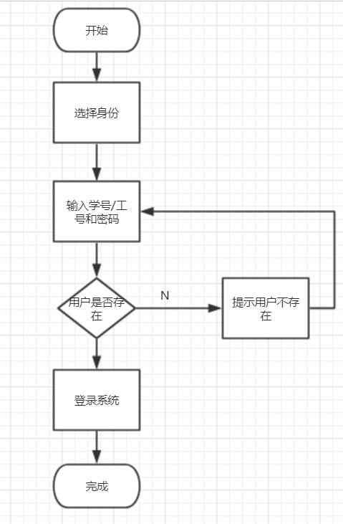

图2-2 登录流程图

### 2.3.2 学生

登录成功后，就可以选择想要的操作，具体操作如图2-5所示

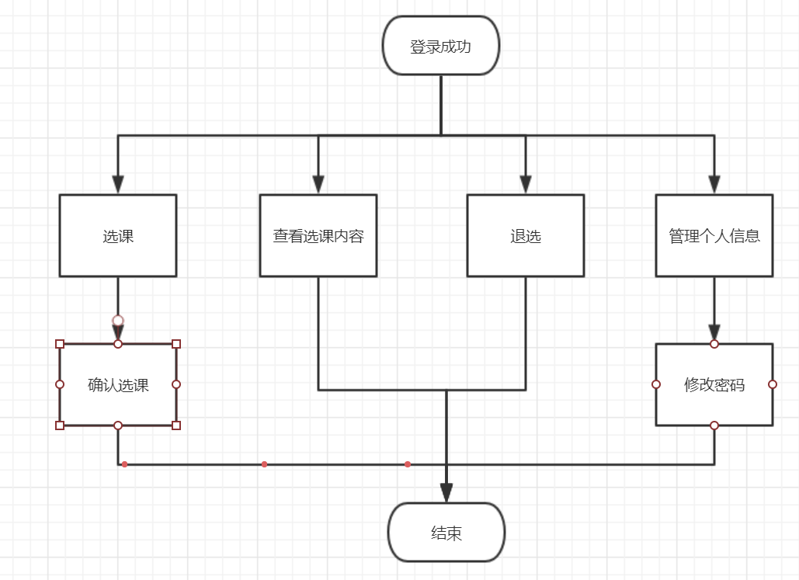

图2-5

### 2.3.3 老师

登录成功后，就可以选择想要的操作，具体操作如图2-6所示

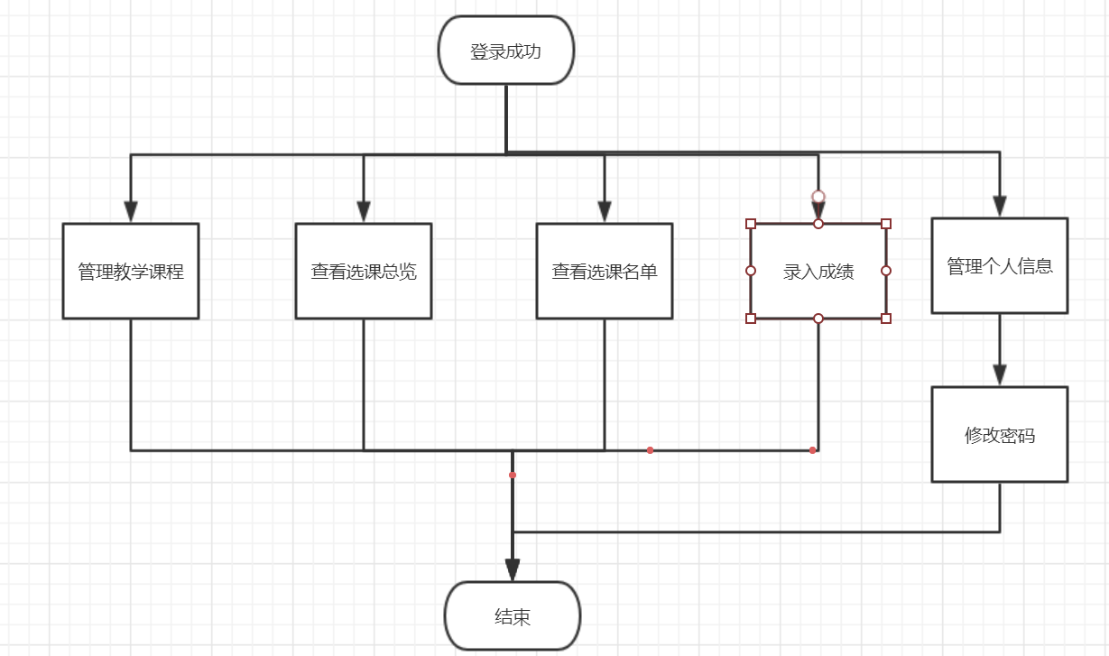

图2-6

### 2.3.4 管理员

登录成功后，就可以选择想要的操作，具体操作如图2-7所示

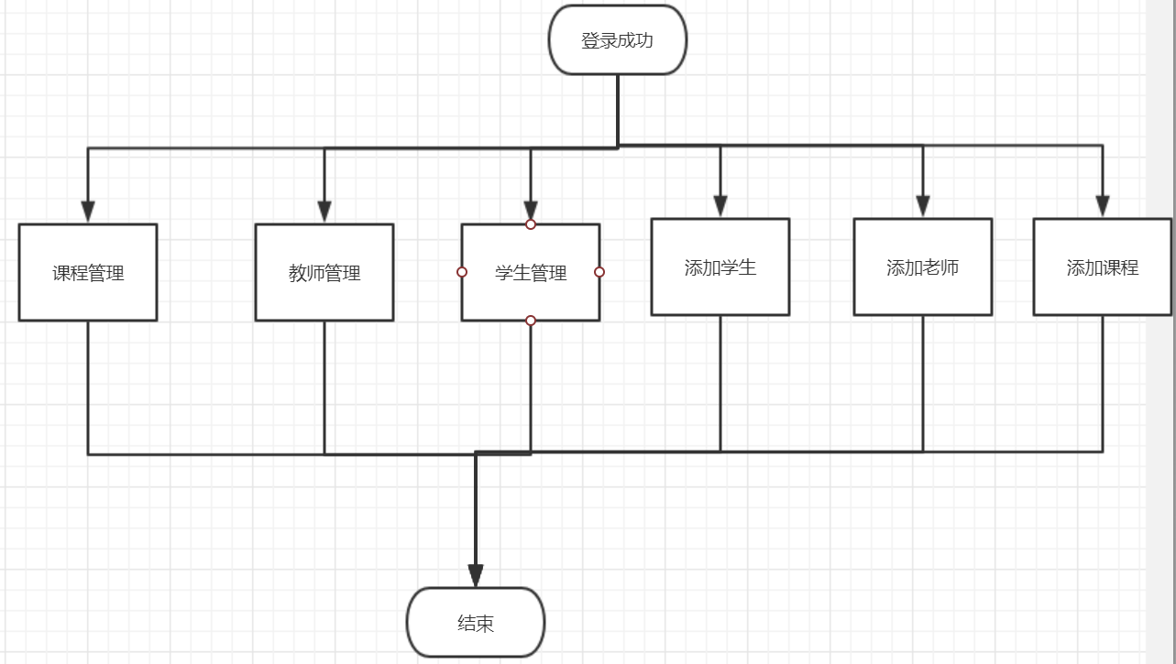

图2-7

# **3 系统实现**

## 3.1 项目结构

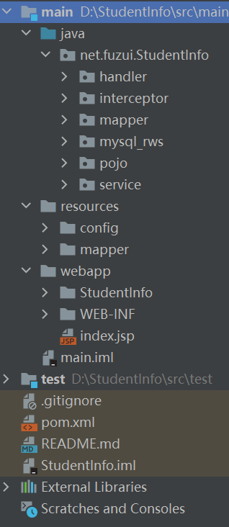

## 3.2 配置文件

在项目下新建Source Folder，名为resources

### 3.2.1 logback.xml文件

该配置文件主要是更新日志，file过滤某些不要的东西，只需修改配置文件而不用修改源代码，增加程序的可扩展型。

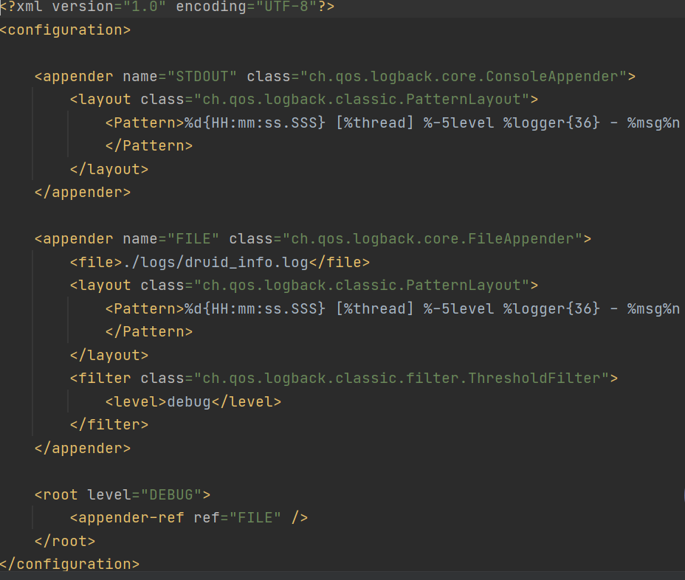，

### 3.2.2 mybatis-config.xml文件

个性化配置文件，handler属性直接配置我们要指定的TypeHandler，plugins分页参数合理化。

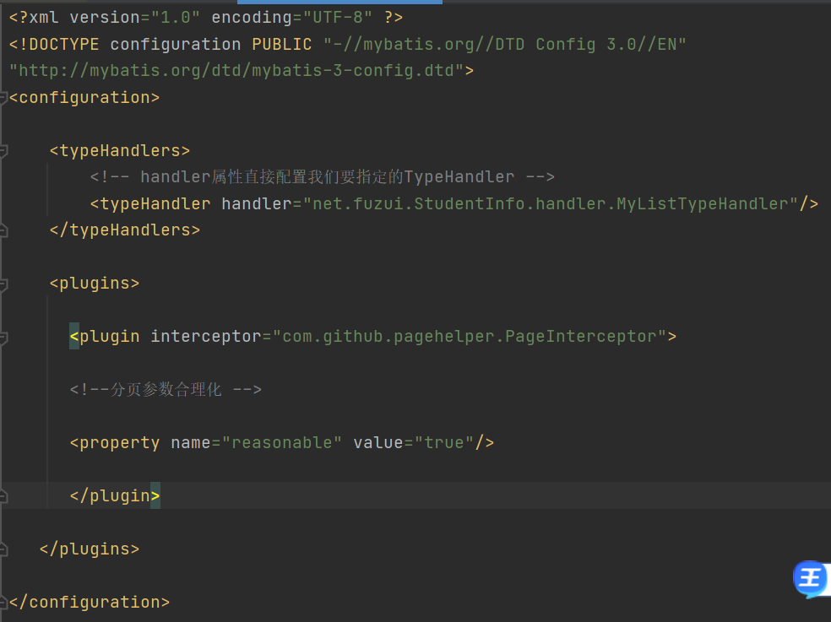

### 3.2.3 applicationContext.xml文件

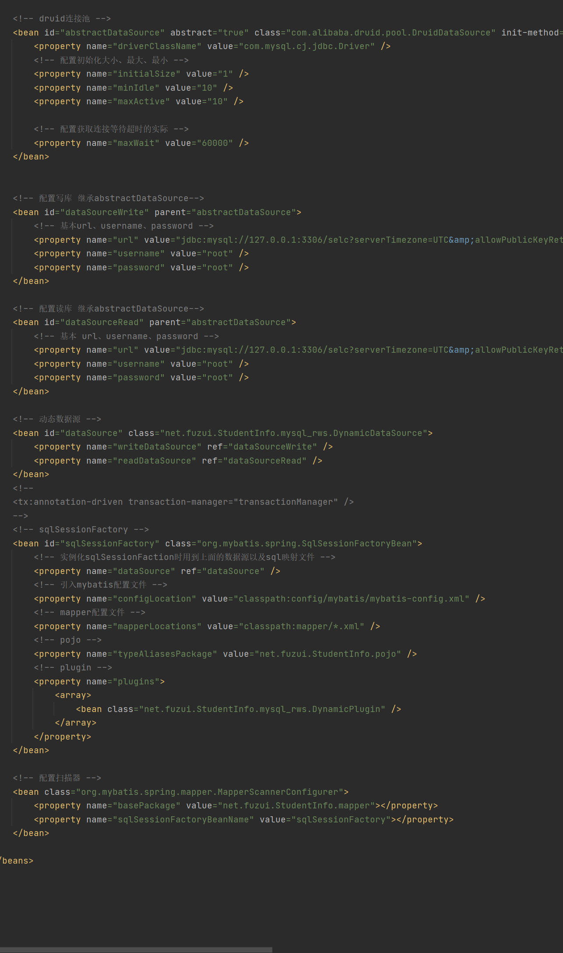

### 3.2.4springMVC.xml文件

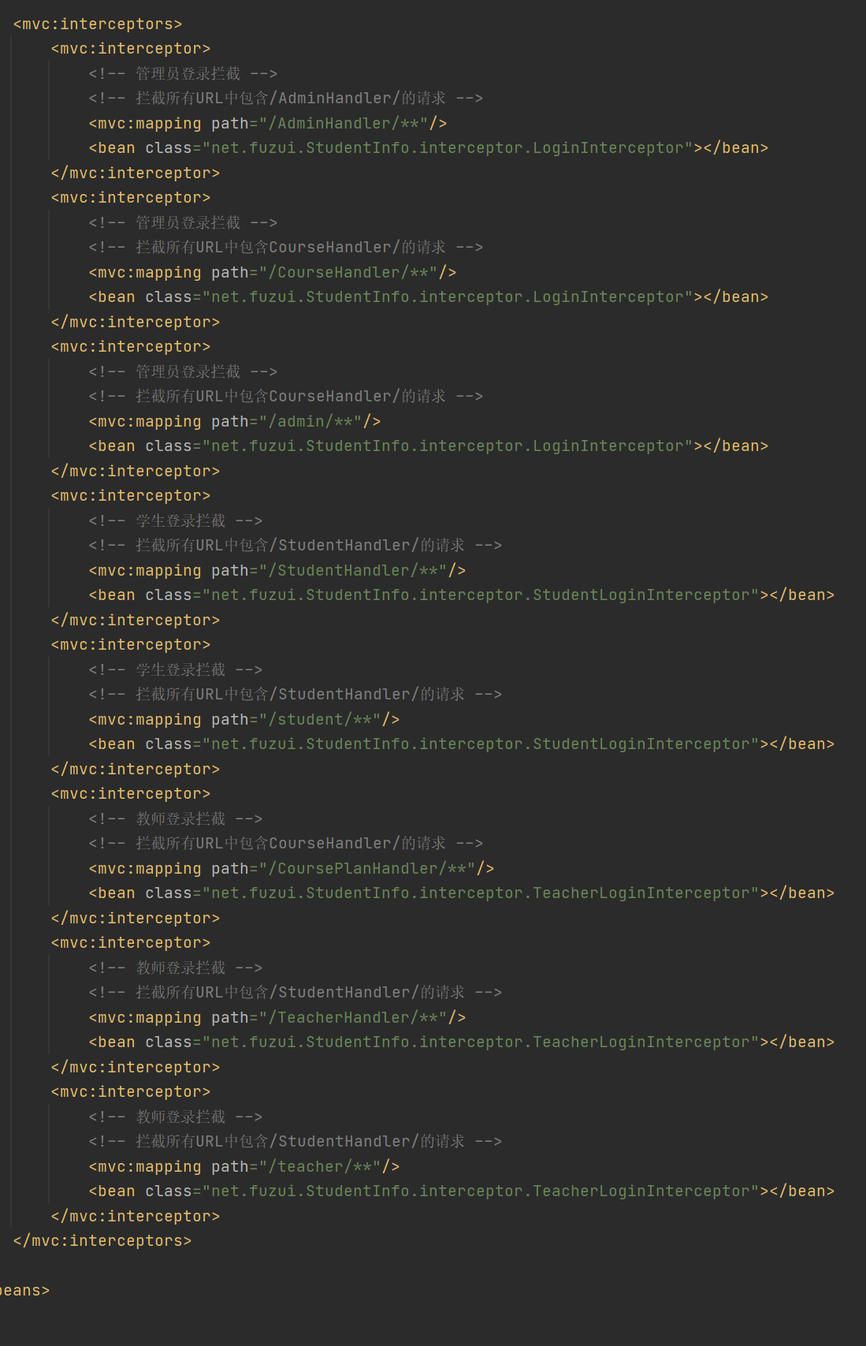

### 3.2.5AdminMapper.xml文件

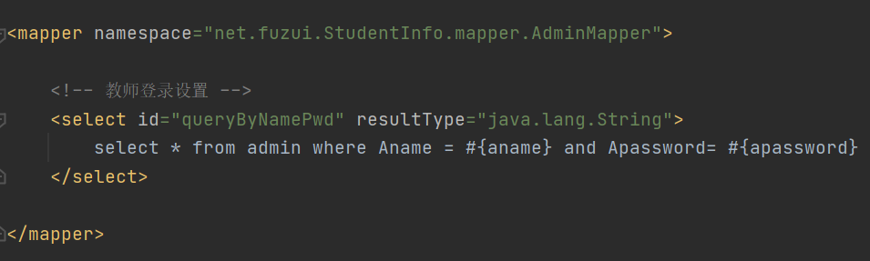

### 3.2.6CourseMapper.xml文件

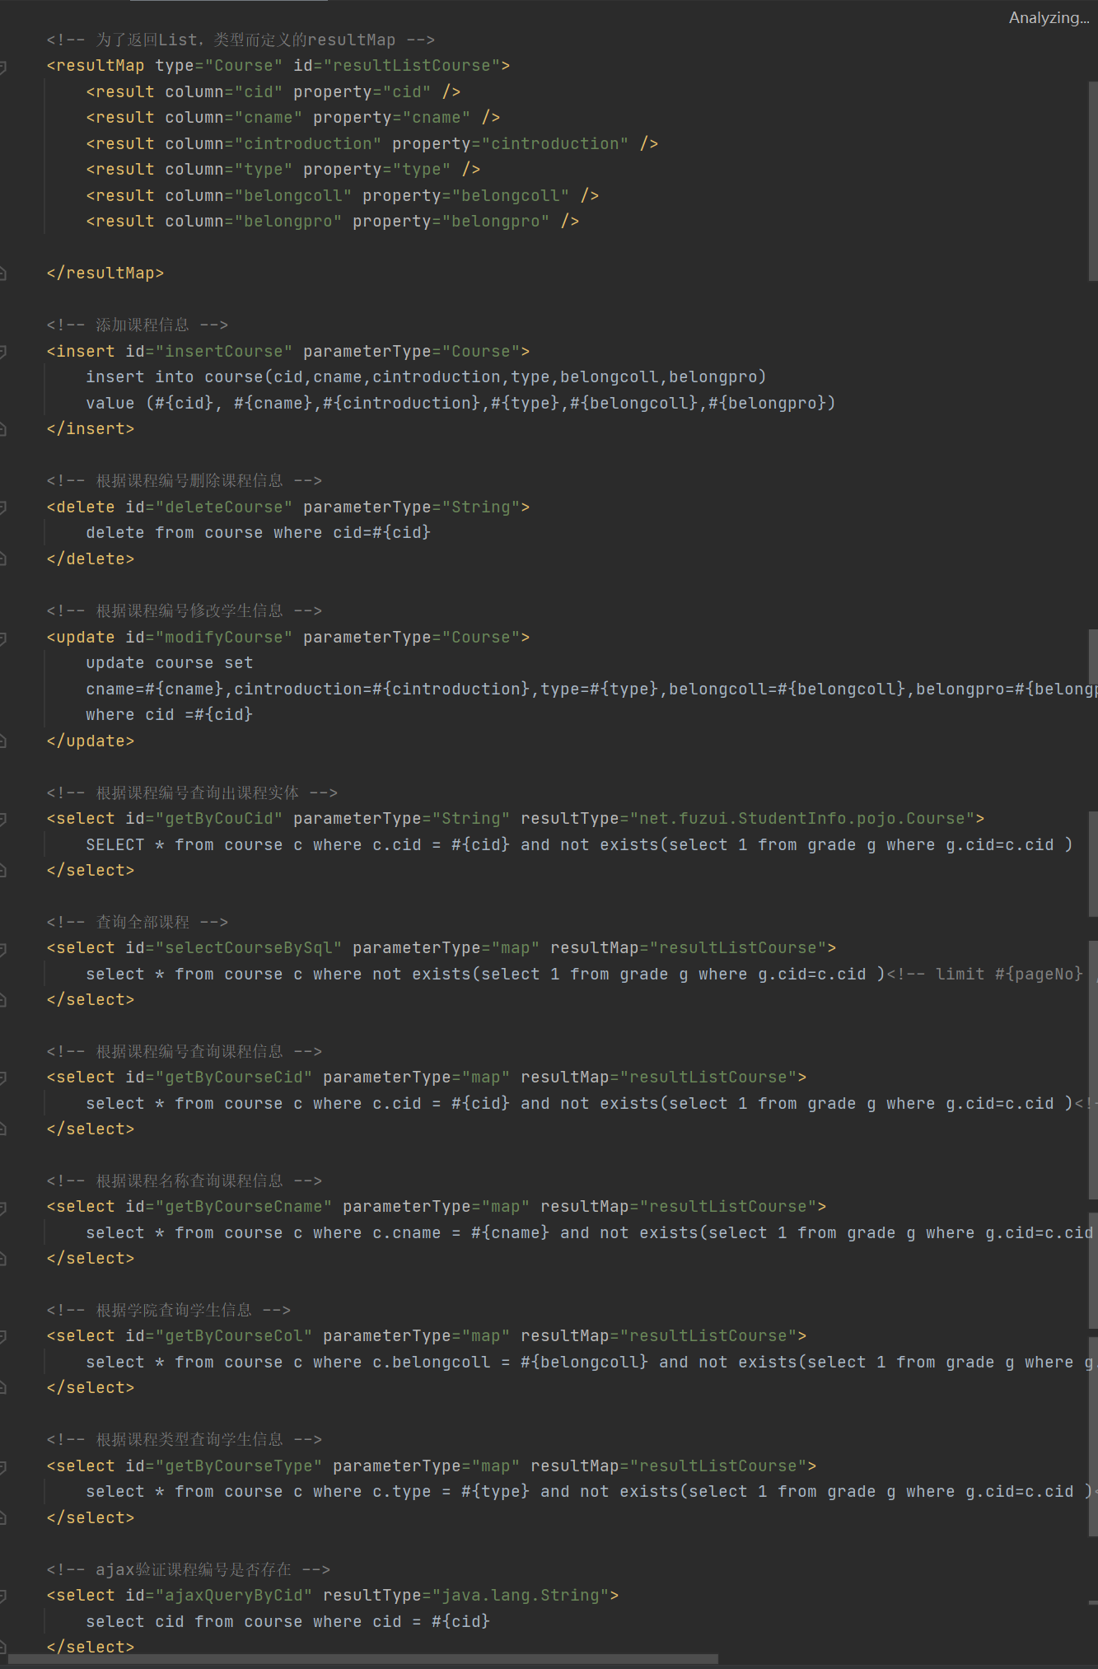

### 3.2.7CoursePlanMapper.xml文件

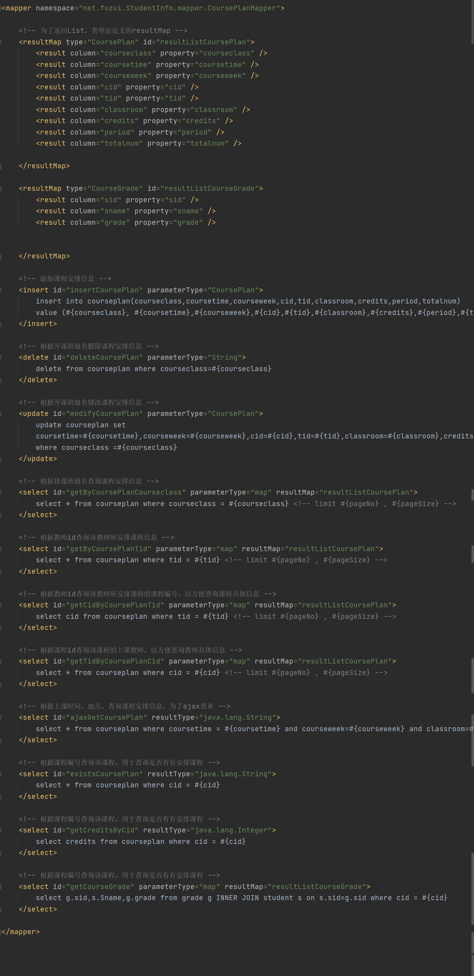

### 3.2.8GradeMapper.xml文件

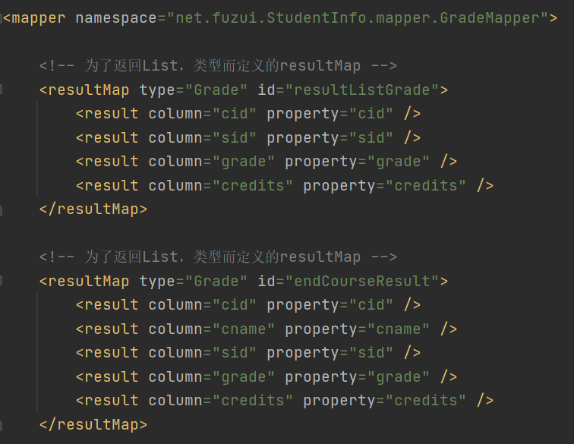

### 3.2.9SelectCourseMapper.xml文件

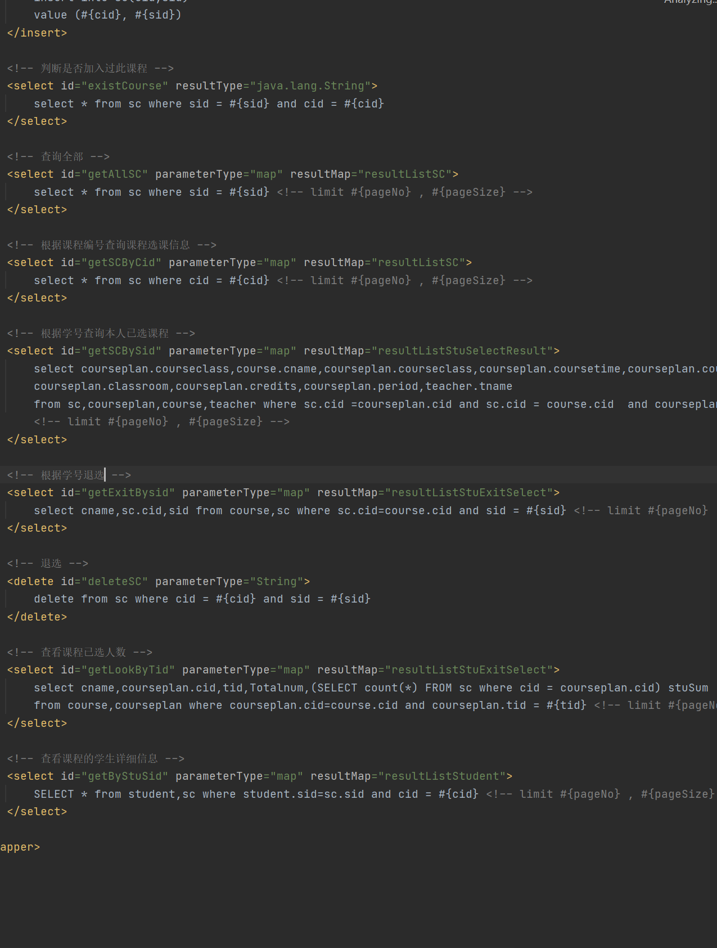

### 3.2.10StudentMapper.xml文件

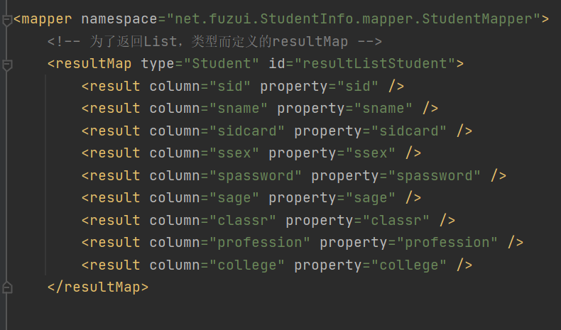

### 3.2.11TeacherMapper.xml文件

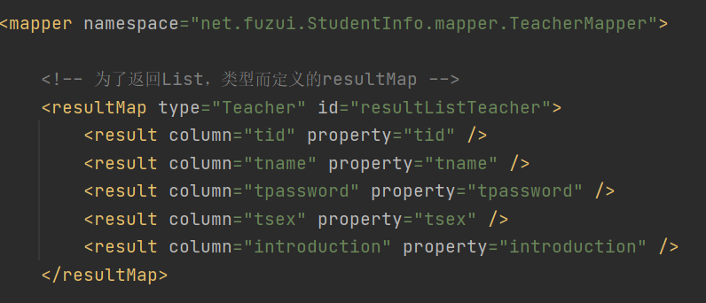

## 3.3 hander类

用户进行的各种操作

1. 管理员进行的各种操作

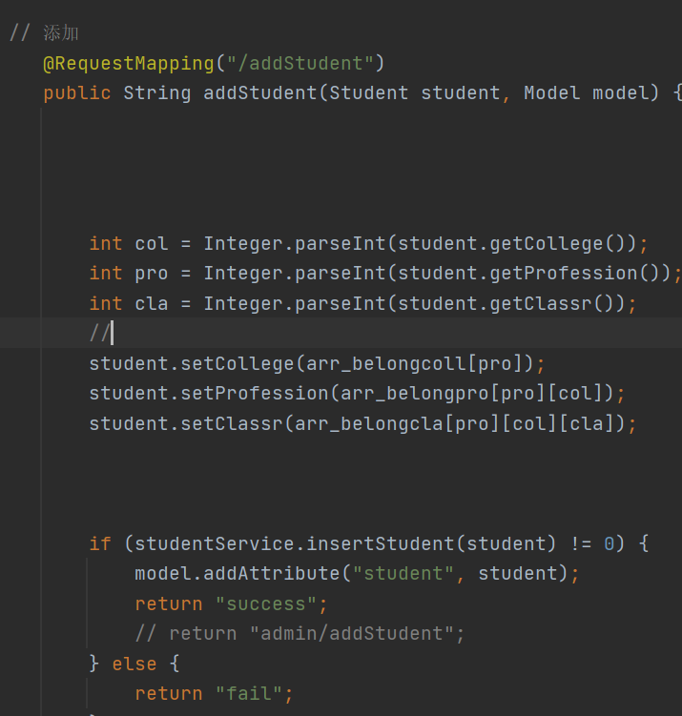

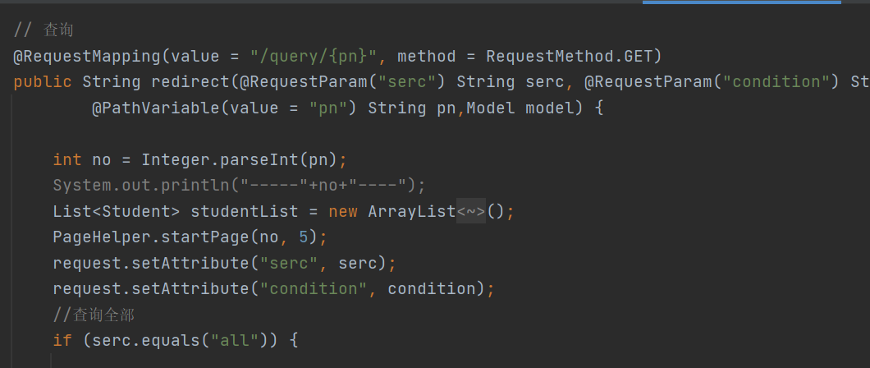

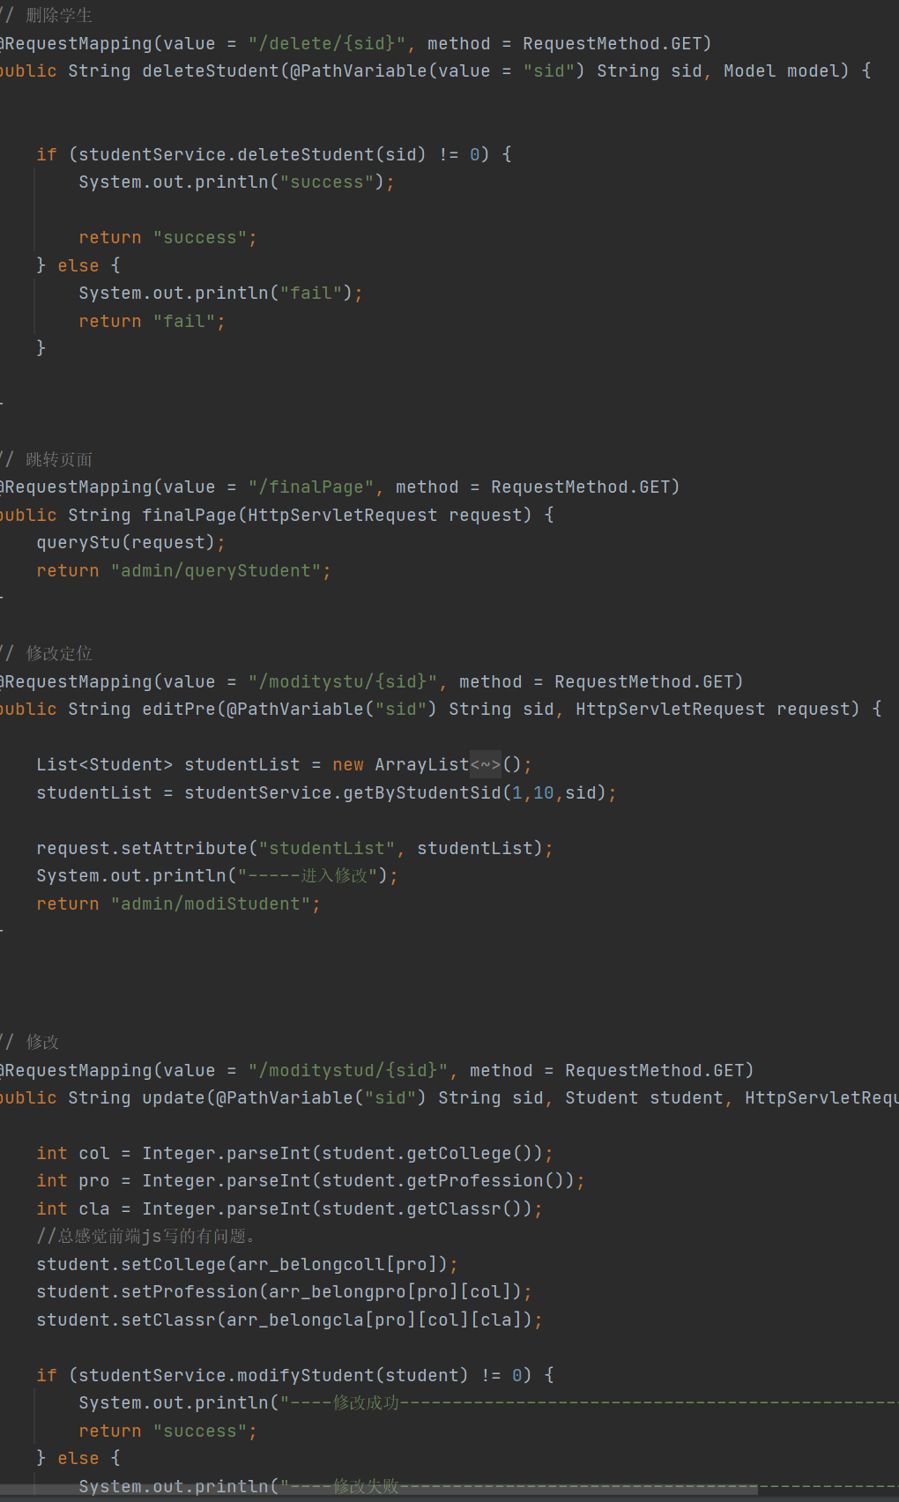

1. ajax验证课程编号是否存在

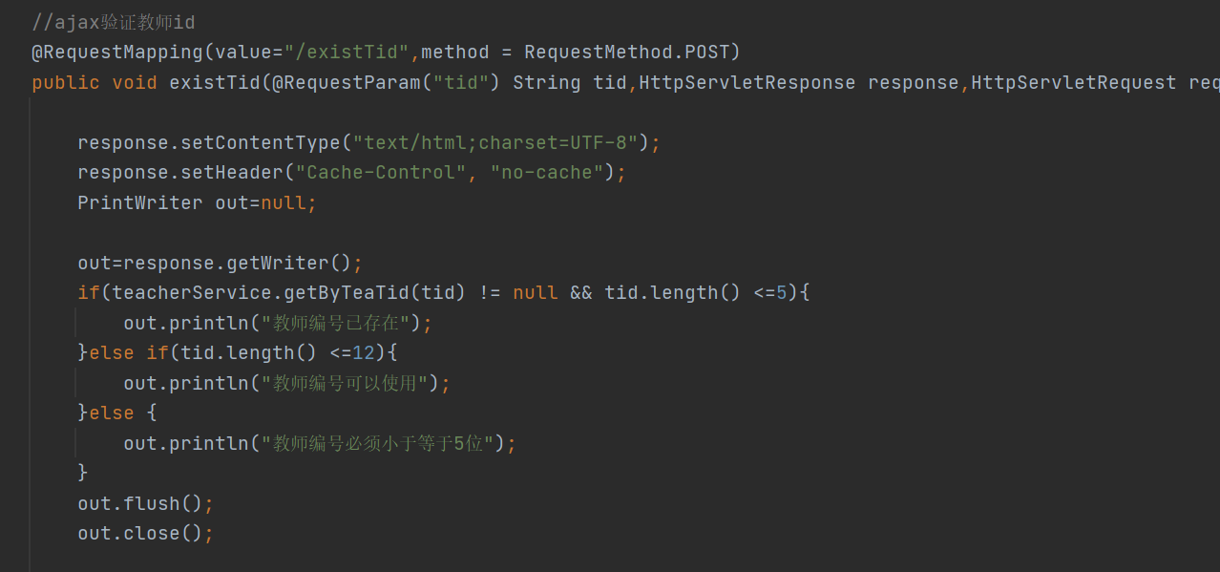

## 3.4 intercaptor类

接口映射类

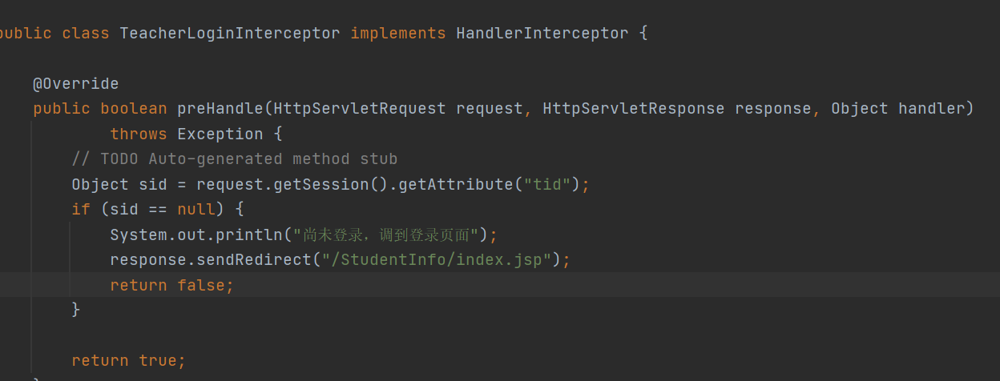

# **4 系统测试**

1. **学生**

**选择学生身份进行登录，如图1-1所示**

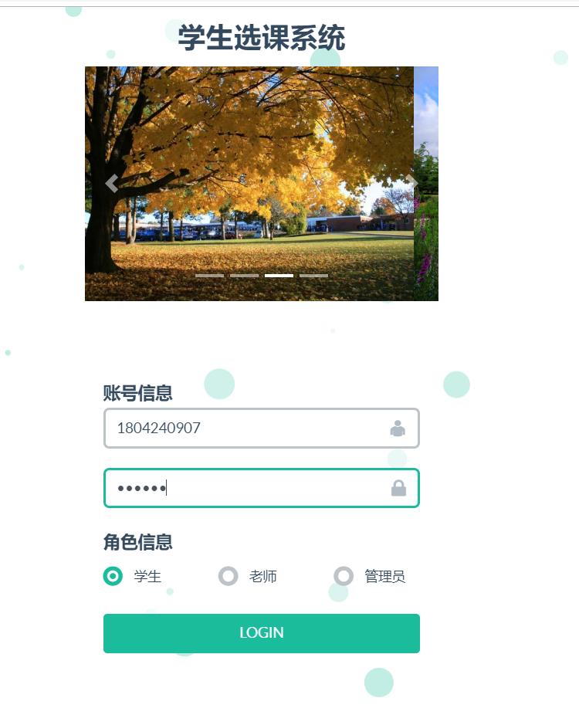

**1-1登录页面**

对所选科目进行确认或者退选

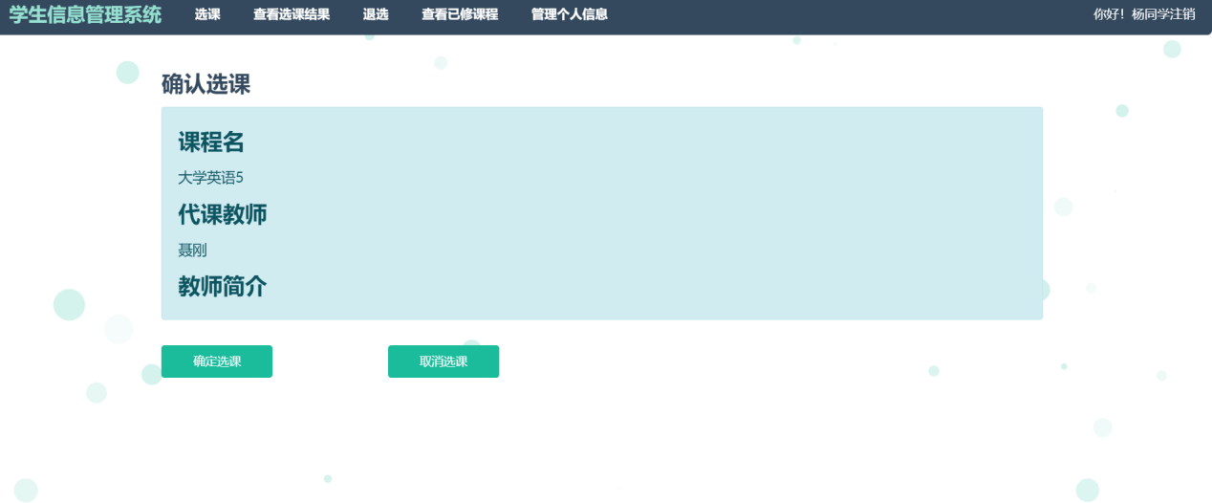

**查看选课结果**

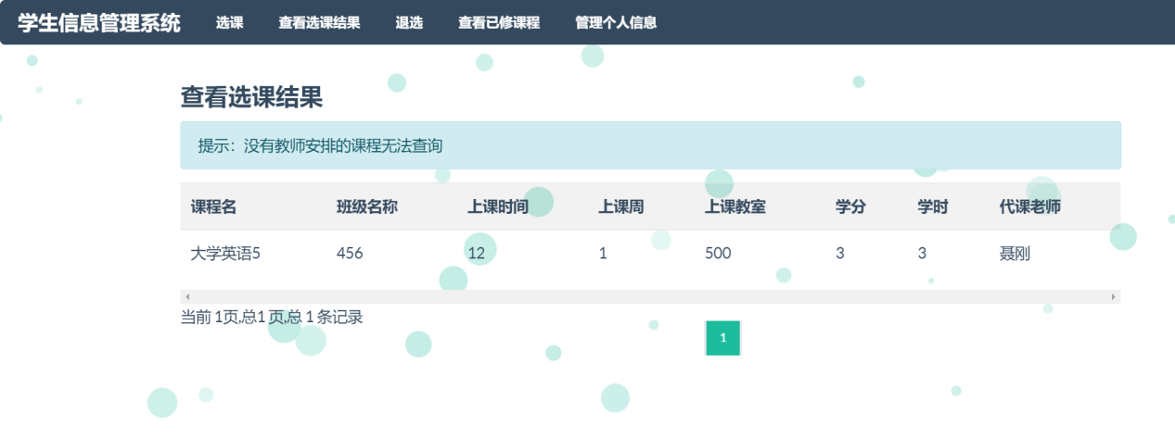

可对所选科目进行退选

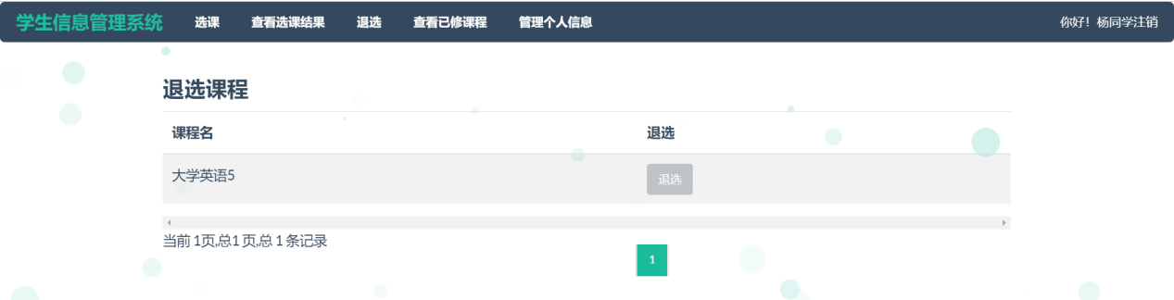

查看个人信息，可进行修改密码操作

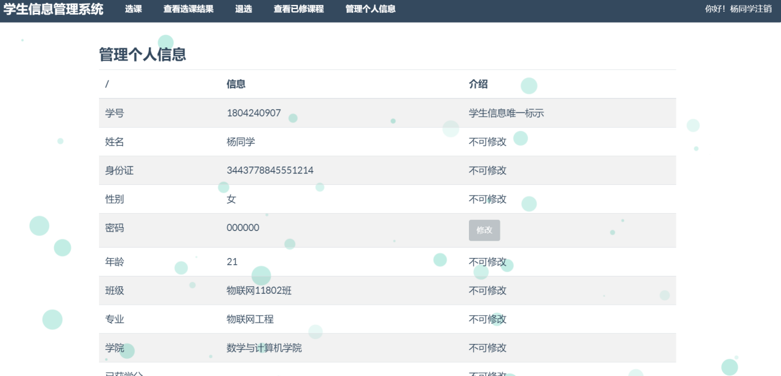

1. **老师**

选择老师身份进行登录，如图2-2所示

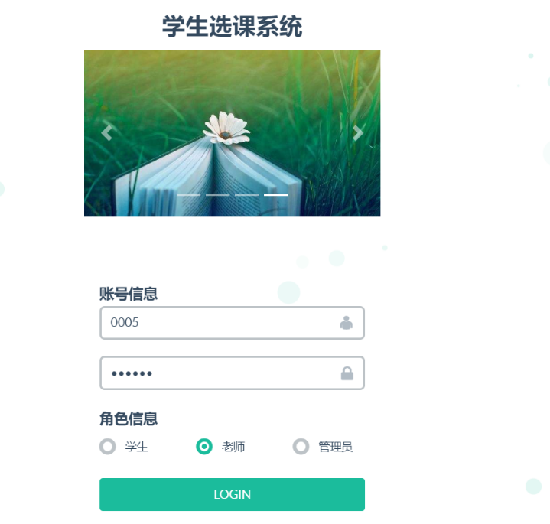

图2-1登录

欢迎页面

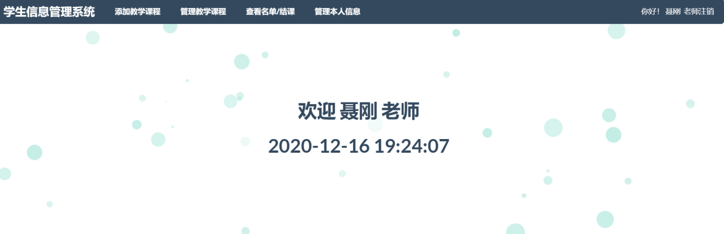

管理教学的课程

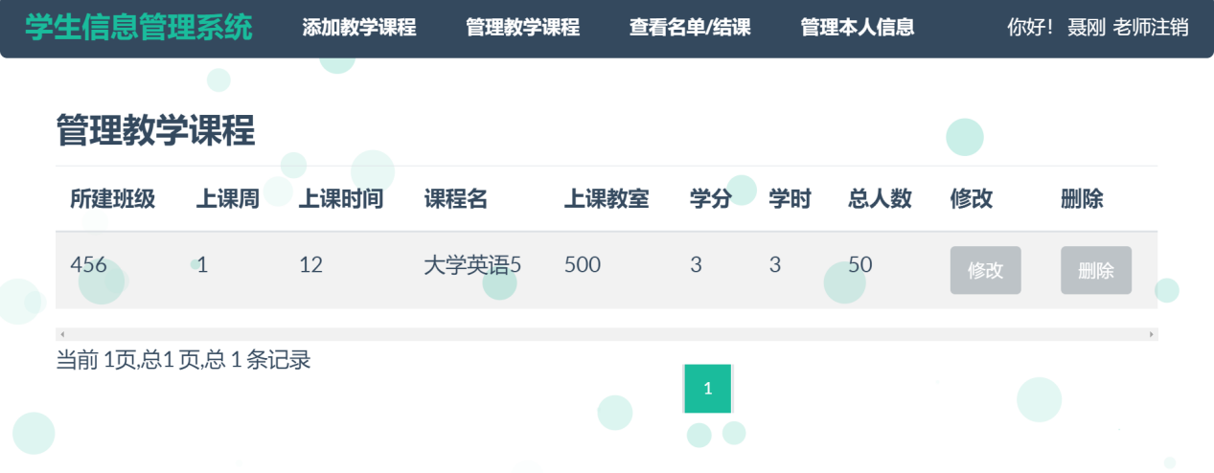

查看选课的总览

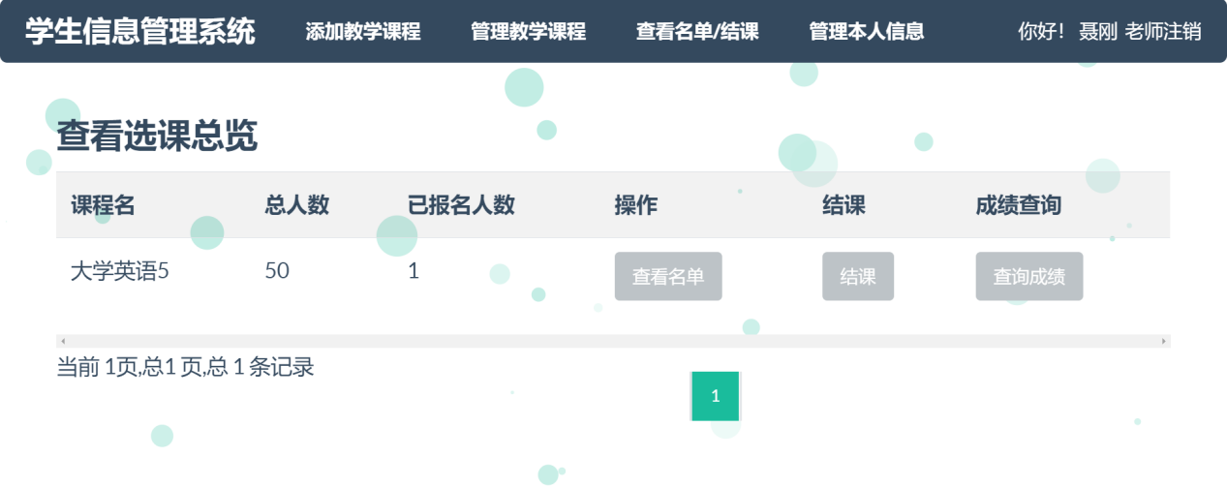

查看选课的名单，这里有点问题，姓名显示只显示姓

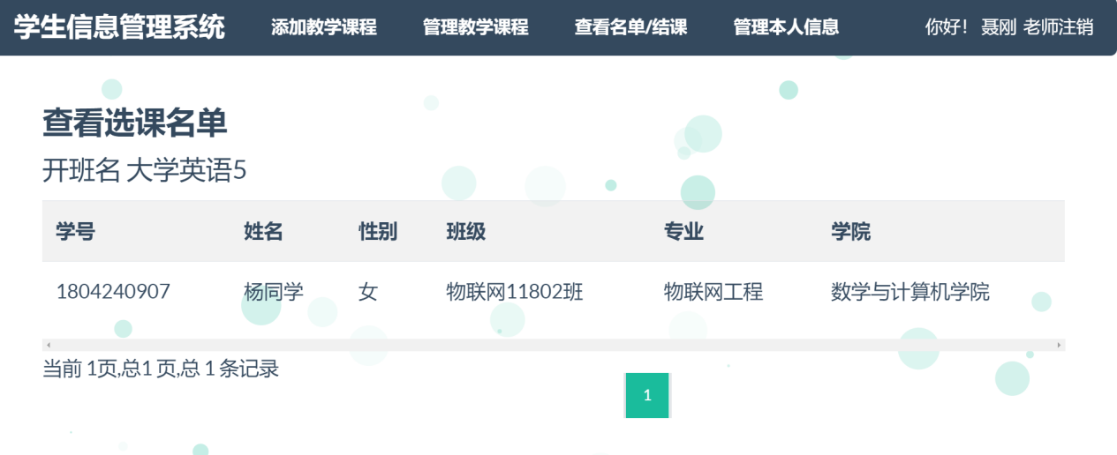

对所教的同学录入成绩

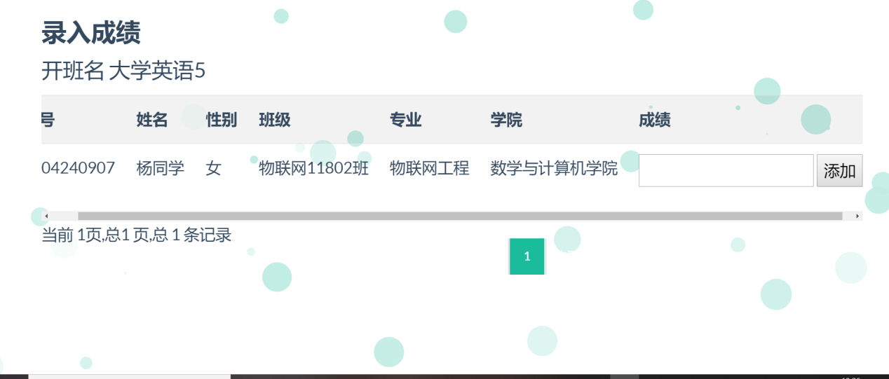

管理自己的信息，进行密码的修改

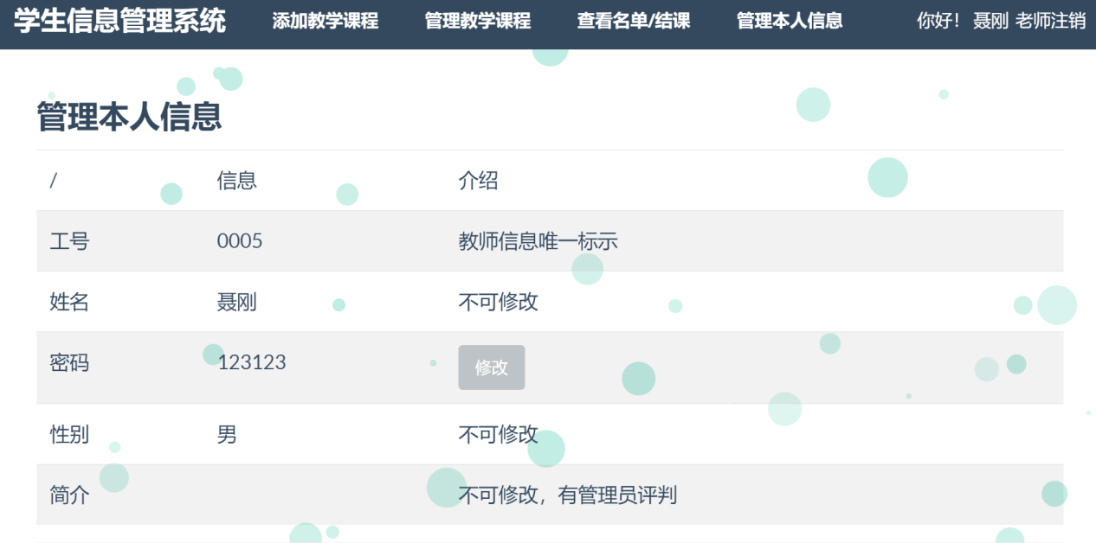

1. **管理员**

选择管理员身份进行登录，登录页面如下图所示

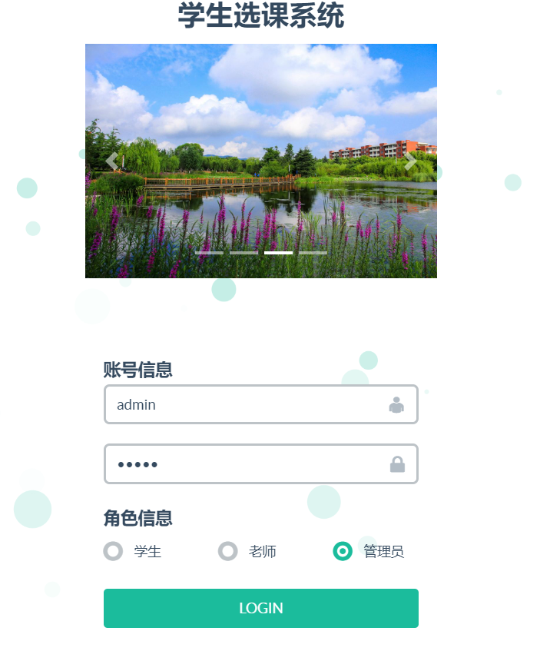

欢迎页面

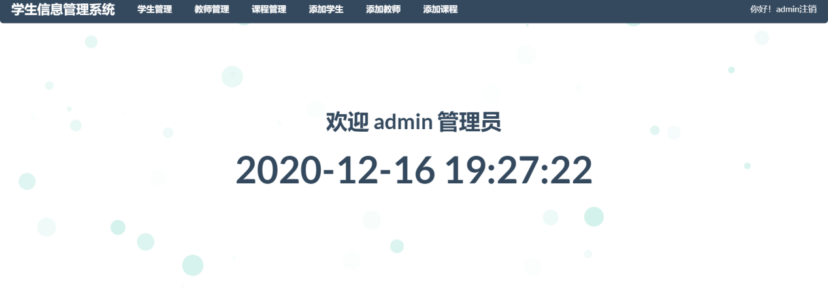

对学生进行管理

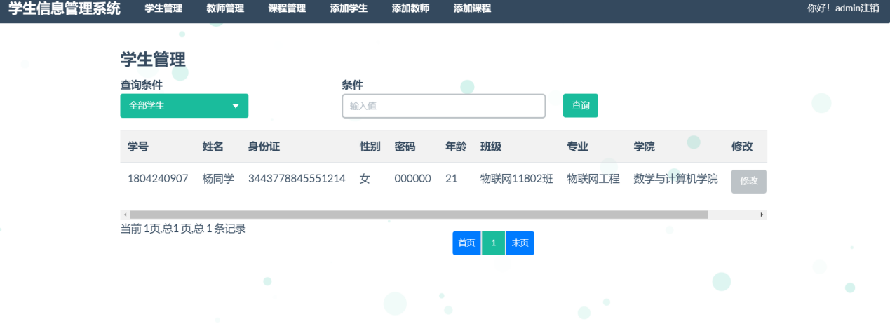

对课程进行管理

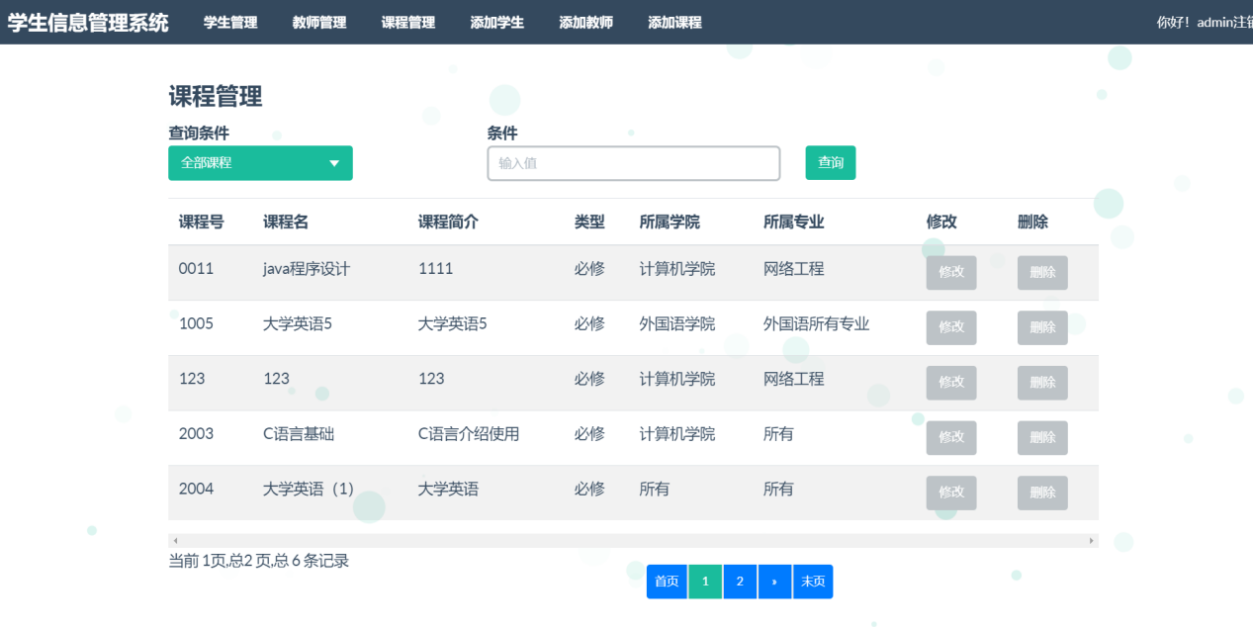

进行学生的添加

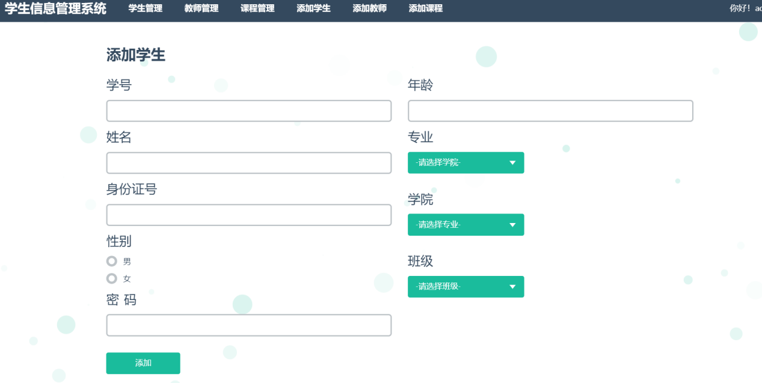

对教师进行添加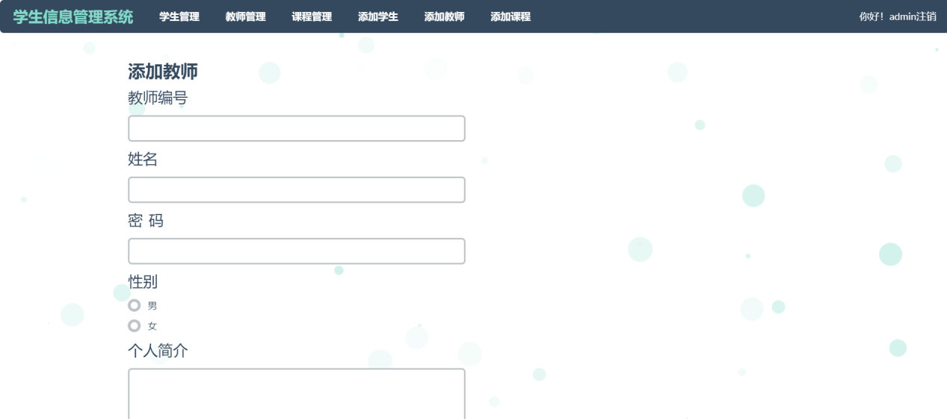

对课程进行添加

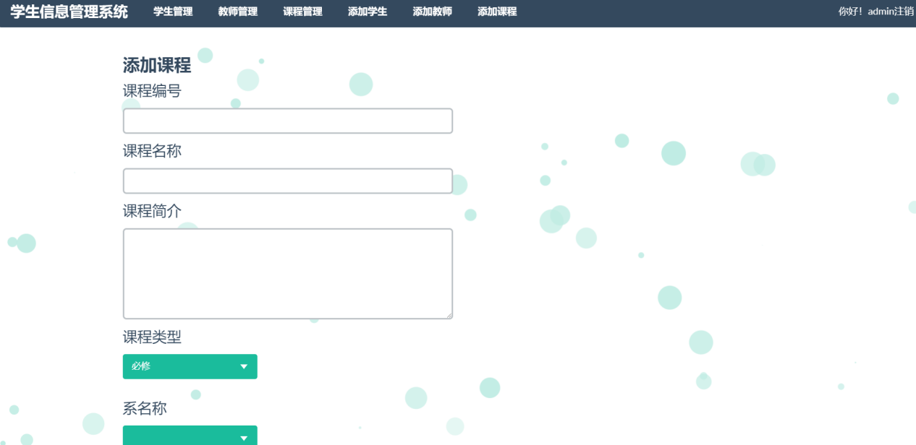

# **5 系统总结**

本次课设遇到了很多问题，从搭框架开始就遇到了很多麻烦，从查阅文档一步步的搭，然后报错，查资料，在同学的帮助下终于把框架搭起来了，还是很有成就感的，然后在写代码的时候，有很多小细节没有弄好，比如欢迎同学的页面，会有欢迎同学同学的情况出现，然后查询成绩这个功能写的不是很好，总的来说，整个系统写得不是很完善。在web课程学到了很多，在大二上的时候，我们就学习了前端，但是当时课太多，学到的只是皮毛，也掌握的不是很好，然后在web课上对之前所学的前端进行了巩固，也对后端的学习有了很大的进展。代码的学习任重而道远，想要学好，是要花不少功夫的，也要靠平时的多练习，不仅要在课上认真听讲，作业认真完成，我对我的课设的自评是良好吧，有很多不足之处需要改善，这良好中有大部分是占平时的分，上课都去了，作业也有完成，希望自己的不足之处能再少一点，能力再提高一点吧。